

SAVEETHA INSTITUTE OF MEDICAL AND TECHNICAL SCIENCES SAVEETHA SCHOOL OF ENGINEERING
DEPARTMENT OF ELECTRONICS AND COMMUNICATION ENGINEERING

ECA08 - ANALOG AND DIGITAL COMMUNICATION
LAB MANUAL

LIST OF EXPERIMENTS

SL. NO. | NAME OF THE EXPERIMENT | HARDWARE/SOFTWARE
1 | AMPLITUDE MODULATION  1.1. AM generation and Detection using AM trainer kit.  1.2 Characteristics study of Side Band power and Frequencies in AM using MATLAB | HARDWARE  SOFTWARE
2 | FREQUENCY MODULATION  2.1. Generation and Analysis of Frequency Modulated (FM) Signals Using MATLAB  2.2. Calculation and Verification of Frequency Deviation and Modulation Index of FM Signals Using MATLAB Simulation | SOFTWARE  SOFTWARE
3 | 3. PHASE MODULATION  3.1. Generation of Phase Modulated (PM) Signals and Calculation of Phase Deviation Using MATLAB Simulation  3.2. Power Spectral Density (PSD) Analysis of Phase Modulated (PM) Signals Using MATLAB | SOFTWARE  SOFTWARE
4 | 4. SAMPLING  4.1. Generation, Sampling, and Reconstruction of Signals Using Sampling and Reconstruction Trainer kit | HARDWARE
5 | 5. BASEBAND TRANSMISSION  5.1. Generation and Decoding of Pulse Code Modulation (PCM) Signals Using a PCM Trainer Kit  5.2. To generate and analyze Delta Modulation (DM) signals using a DM trainer kit | HARDWARE  HARDWARE
6 | 6. PASSBAND TRANSMISSION  6.1. Generation and Detection of Amplitude Shift Keying (ASK) Signals Using a Digital Communication Trainer Kit  6.2. Generation and Detection of Frequency Shift Keying (FSK) Signals Using a Digital Communication Trainer Kit  6.3. Generation and Detection of Phase Shift Keying (PSK) Signals Using a Digital Communication Trainer Kit | HARDWARE  HARDWARE  HARDWARE
7 | 7. MULTIPLEXING METHOD  7.1. Generation and Analysis of Time Division Multiplexed Signals Using a Digital Communication Trainer Kit. | HARDWARE
8 | 8. CONSTELLATIONS  8.1. Simulation and Analysis of BPSK Modulation Using Constellation Diagrams in MATLAB.  8.2. Simulation and Analysis of QPSK Modulation Using Constellation Diagrams in MATLAB. | SOFTWARE  SOFTWARE
9 | 9. CONVOLUTIONAL CODES  9.1. Simulation of Convolutional Codes and Analysis of Encoded Output Bit Sequences Using MATLAB | SOFTWARE
10 | 10. SPREAD SPECTRUM MODULATION  10.1. Calculation of Processing Gain and Generation of PN Sequences for Spread Spectrum Communication Using MATLAB Simulation. | SOFTWARE

EX NO: 1a | AM GENERATION AND DETECTION USING AM TRAINER KIT
DATE:

Objectives
i) Calculate the modulation index of an AM signal from carrier and modulating signal parameters.
ii) Identify and analyze the condition of under modulation by evaluating the modulation index (m < 1).
iii) Determine the critical modulation condition (m = 1) and examine its significance in achieving maximum undistorted modulation.
iv) Evaluate the effects of over modulation (m > 1) on the AM waveform and analyze the resulting signal distortion.

Objective 1: Calculate the Modulation Index of an AM Signal
Procedure:
- Connect the AM modulator circuit with the carrier and modulating signal sources.
- Set the carrier frequency and modulating frequency to the specified values.
- Observe the AM waveform on the DSO.
- Measure the maximum amplitude V_{max} and minimum amplitude V_{min}​ of the modulated waveform.
- Calculate the modulation index using:
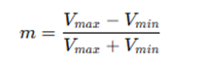
- Record the calculated value and verify the result.

Model Graph

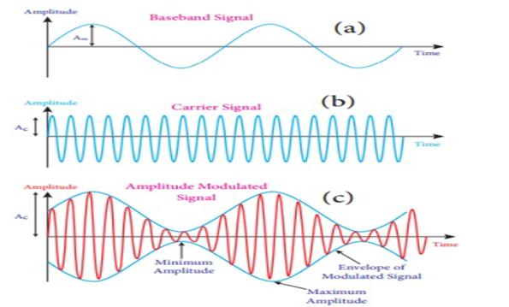
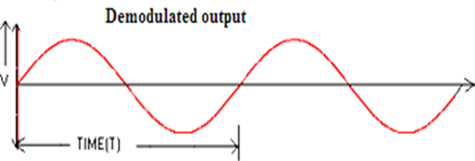
Tabular Column

Waveform | Amplitude (V) | Time Period (msec) | Frequency
Message signal
Carrier signal
Modulated Signal | V_{max}=  V_{min}=
Demodulated Signal

Example (Just for Understanding):
The modulation index of an AM signal can be determined from the envelope of the waveform using:
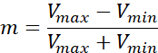
where:
· = Maximum envelope voltage
· = Minimum envelope voltage
Result
The modulation index of the AM signal was successfully calculated using the amplitudes of the carrier and modulating signals.

Block Diagram

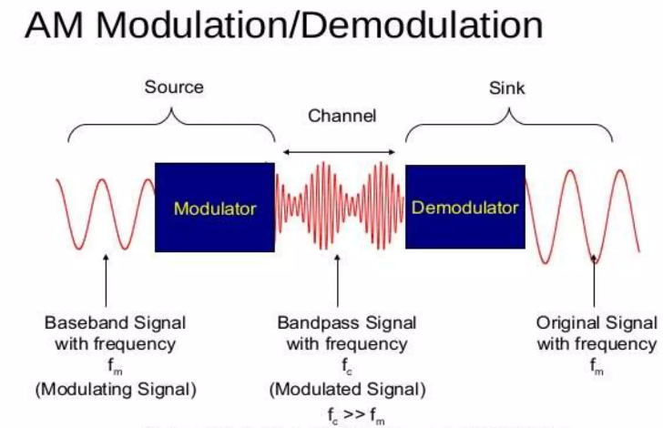

Objective 2: Analyze the Condition of Under Modulation (m < 1)
Procedure:
- Set up the AM modulation circuit.
- Apply a modulating signal with amplitude lower than the carrier amplitude.
- Observe the AM waveform on the DSO.
- Measure V_{max} and V_{min} ​ from the envelope.
- Calculate the modulation index and confirm that m<1.
- Sketch or capture the waveform and note the characteristics of under modulation.
Model Graph
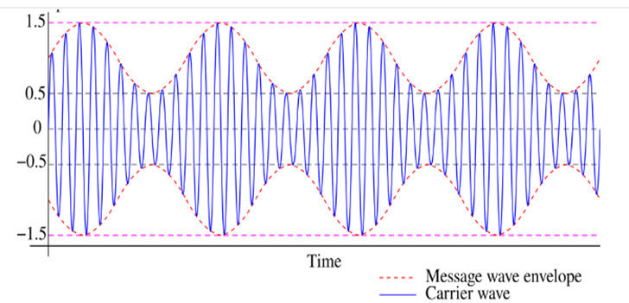
Tabular Column
Waveform | Amplitude (V) | Time Period  (msec) | Frequency
Message signal
Carrier signal
Modulated Signal | V_{max}=  V_{min}=

Example (Just for Understanding):
Under Modulation ()
Given:
- V
- V
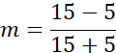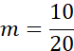
Result: (50% modulation) → Under Modulation

Result:
The AM signal was observed to be under-modulated when the modulation index was less than one, resulting in a distortion-free but low-power transmission.

Objective 3: Determine the Critical Modulation Condition (m = 1)
Procedure:
- Configure the AM modulator and apply the carrier signal.
- Gradually increase the amplitude of the modulating signal.
- Observe the envelope of the AM waveform continuously on the DSO.
- Adjust the modulating signal until the envelope just touches the zero axis without distortion.
- Measure V_{max} and V_{min} ​ and calculate the modulation index.
Verify that the modulation index is approximately equal to 1 and record the observations.
Model Graph
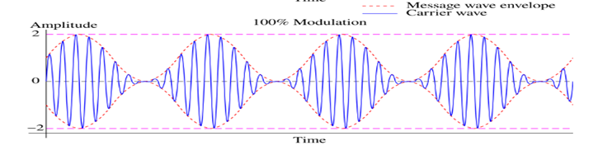

Tabular Column

Waveform | Amplitude (V) | Time Period  (msec) | Frequency
Message signal
Carrier signal
Modulated Signal | V_{max}=  V_{min}=
Example (Just for Understanding):
Critical Modulation ()
Given:
- V
- V
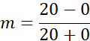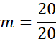
(100% modulation) → Critical Modulation
Results:
At a modulation index of one, the AM signal achieved 100% modulation, providing maximum undistorted transmission efficiency
Objective 4: Evaluate the Effects of Over Modulation (m > 1)
Procedure:
- Connect the AM modulation setup and apply the carrier signal.
- Increase the modulating signal amplitude beyond the carrier amplitude.
- Observe the AM waveform on the DSO.
- Measure V_{max}​ and V_{min} ​ and calculate the modulation index.
- Verify that the modulation index is greater than 1.
- Observe and record the envelope distortion caused by over modulation.
- Sketch or capture the distorted waveform and discuss its effect on signal quality.
Model Graph
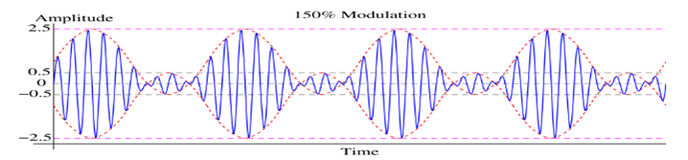
Tabular Column

Waveform | Amplitude (V) | Time Period  (msec) | Frequency
Message signal
Carrier signal
Modulated Signal | V_{max}=  V_{min}=

Example (Just for Understanding):
Over Modulation ()
In practice, when over modulation occurs, the envelope becomes distorted and cannot be measured correctly from the envelope. Therefore, the - method is valid only up to .
For example, if:
- Carrier amplitude V
- Modulating amplitude V
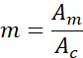
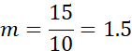Result: → Over Modulation, causing envelope distortion and improper demodulation.
Result:
When the modulation index exceeded one, over-modulation occurred, causing envelope distortion and improper recovery of the message signal.

Question 1
In the laboratory, generate an Amplitude Modulated (AM) signal using a 1 MHz carrier signal and a 1 kHz sinusoidal message signal. Observe and plot the modulated and demodulated waveforms using the experimental setup. Determine the modulation index and identify the modulation condition by measuring the envelope voltages of the AM waveform..
Case 1:
· Measured Maximum Envelope Voltage, V
· Measured Minimum Envelope Voltage, V
Case 2:
· Measured Maximum Envelope Voltage, V
· Measured Minimum Envelope Voltage, V
Case 3:
· Carrier Amplitude, V
· Modulating Signal Amplitude, V
Tasks:
1. Generate the AM waveform using the given carrier and message signal frequencies.
2. Observe and plot the AM modulated waveform.
3. Demodulate the AM signal and plot the recovered message signal.
4. Calculate the modulation index for each case.
5. Identify whether the signal is under-modulated, critically modulated, or over-modulated.

Aim  (10) | Tabular Column/ Program  (20) | Procedure/Calculations  (20) | Results  (20) | Record  (10) | Viva  (20) | Total  (100)

Question 2
In the laboratory, generate an Amplitude Modulated (AM) signal using a carrier frequency of 800 kHz and a message signal frequency of 2 kHz. Observe the modulated and demodulated waveforms and determine the modulation index for the following cases. Identify whether the signal is under-modulated, critically modulated, or over-modulated.
Case 1:
· Measured Maximum Envelope Voltage, V
· Measured Minimum Envelope Voltage, V
Case 2:
· Measured Maximum Envelope Voltage, V
· Measured Minimum Envelope Voltage, V
Case 3:
· Carrier Amplitude, V
· Modulating Signal Amplitude, V
Tasks:
1. Generate the AM waveform using the given carrier and message signal frequencies.
2. Plot the message signal, carrier signal, and modulated waveform.
3. Demodulate the AM signal and plot the recovered message signal.
4. Calculate the modulation index for each case.
5. Identify the modulation condition (under, critical, or over modulation).

Aim  (10) | Tabular Column/ Program  (20) | Procedure/Calculations  (20) | Results  (20) | Record  (10) | Viva  (20) | Total  (100)

EX NO: 1b | CHARACTERISTICS STUDY OF SIDE BAND POWER AND FREQUENCIES IN AM USING MATLAB
DATE:

Objectives:
i) To generate an Amplitude Modulated (AM) signal in MATLAB using specified carrier and modulating signal parameters.
ii) To determine and verify the upper sideband (USB) and lower sideband (LSB) frequencies of the AM signal using frequency spectrum analysis in MATLAB.
iii) To calculate the carrier power, sideband power, and total transmitted power of the AM signal for a given modulation index using MATLAB.
iv) To analyze the effect of varying the modulation index on sideband power distribution and overall transmission efficiency through MATLAB simulation.

Objective 1:
To generate an Amplitude Modulated (AM) signal in MATLAB using specified carrier and modulating signal parameters
PROGRAM (MATLAB CODE)
clc;
clear;
close all;
Am=1;
fm=500;
Ac=5;
fc=5000;
fs=20*fc;
t=0:1/fs:4/fm;
m = Am*sin(2*pi*fm*t);
c = Ac*sin(2*pi*fc*t);
mu = Am/Ac;
am = Ac*(1+mu*sin(2*pi*fm*t)).*sin(2*pi*fc*t);
dem = abs(hilbert(am)); dem = dem-mean(dem);
N=length(am); f=linspace(-fs/2,fs/2,N);
AM_FFT=abs(fftshift(fft(am)))/N;
USB=fc+fm; LSB=fc-fm;
Pc=Ac^2/2; Psb=(mu^2*Pc)/4;
figure('Name','AM Modulation','NumberTitle','off');
subplot(3,2,1), plot(t,m), title('Message'), grid on
subplot(3,2,2), plot(t,c), title('Carrier'), grid on
subplot(3,2,3), plot(t,am), title('AM Signal'), grid on
subplot(3,2,4), plot(t,dem), title('Demodulated'), grid on
subplot(3,2,5), plot(f,AM_FFT), xlim([fc-3*fm fc+3*fm]), title('Sidebands'), grid on
subplot(3,2,6), bar([Pc Psb Psb]), set(gca,'XTickLabel',{'Carrier','USB','LSB'}),
title('Power'), grid on
fprintf('μ=%.2f | USB=%d Hz | LSB=%d Hz | Pc=%.2f W | Psb=%.3f W\n',mu,USB,LSB,Pc,Psb);
Procedure
- Open MATLAB and create a new script file.
- Initialize the MATLAB workspace by clearing all variables, command window contents, and open figure windows using:
clc; clear; close all;
- Define the message signal amplitude (), message frequency (), carrier amplitude (), carrier frequency (), and sampling frequency ().
- Generate the time vector required for signal simulation using the specified sampling frequency.
- Generate the message signal using a sinusoidal waveform with frequency .
- Generate the carrier signal using a sinusoidal waveform with frequency .
- Calculate the modulation index () using:
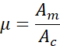
- Generate the Amplitude Modulated (AM) signal using the standard AM equation:
- Demodulate the AM signal using the Hilbert Transform to obtain the envelope of the modulated signal.
- Remove the DC component from the demodulated signal to recover the original message signal.
- Compute the Fast Fourier Transform (FFT) of the AM signal to analyze its frequency spectrum.
- Determine the Upper Sideband (USB) and Lower Sideband (LSB) frequencies using:
- Calculate the carrier power and sideband power using:
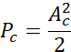
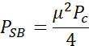
- Plot the message signal, carrier signal, AM signal, demodulated signal, frequency spectrum showing sidebands, and power distribution using MATLAB subplot commands.
- Display the values of modulation index, sideband frequencies, carrier power, and sideband power in the MATLAB Command Window using the fprintf() function.
- Observe and analyze the generated plots to verify the AM waveform characteristics, sideband frequencies, and power distribution.
OUTPUT (GRAPH)
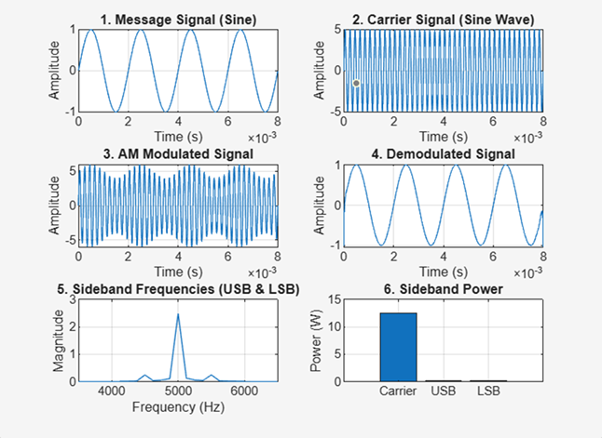
Example (Just for Understanding)
Calculations for Sideband Power and Frequencies in AM
Given:
· Carrier Frequency, Hz
· Modulating Frequency, Hz
· Carrier Power, W
· Modulation Index, (100% modulation)

Result:
The AM signal was successfully generated and analyzed in MATLAB.
Objective 2:
To determine and verify the upper sideband (USB) and lower sideband (LSB) frequencies of the AM signal using frequency spectrum analysis in MATLAB.
Upper Sideband Frequency (USB)
Lower Sideband Frequency (LSB)
Result:
i) Upper Sideband Frequency (USB) = 55 Hz
ii) Lower Sideband Frequency (LSB) = 45 Hz
Objective 3:
To calculate the carrier power, sideband power, and total transmitted power of the AM signal for a given modulation index using MATLAB.
Sideband Power
For an AM signal,
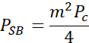
Substituting and W:
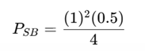
Therefore,
- Upper Sideband Power (USB Power) = 0.125 W
- Lower Sideband Power (LSB Power) = 0.125 W
4. Total Sideband Power
5. Total Transmitted Power
Result
i) Carrier Power = 0.5 W
ii) Upper Sideband Power = 0.125 W
iii) Lower Sideband Power = 0.125 W
iv) Total Sideband Power = 0.25 W
v) Total Transmitted Power = 0.75 W
Question 1
Using MATLAB simulation, for the given parameters, Carrier Amplitude, Ac=10, Carrier Frequency, fc=20kHz, Message Amplitude, Am=5 V, Message Frequency, fm​=1 kHz, Sampling Frequency, fs=200kHz; do the following tasks.

Tasks
- Generate the message signal and carrier signal.
- Generate the AM signal.
- Determine the modulation index.
- Plot the AM waveform.
- Perform FFT analysis.
- Identify carrier, USB, and LSB frequencies.
- Calculate carrier power, sideband power, and total transmitted power.
Aim  (10) | Tabular Column/ Program  (20) | Procedure/Calculations  (20) | Results  (20) | Record  (10) | Viva  (20) | Total  (100)

Question 2

Using MATLAB simulation, for the given parameters, Ac=8 V, Am=6 V, fc=15 kHz, fm=2 kHz, fs=150 kHz, do the following tasks.

Tasks
- Generate the AM signal.
- Verify modulation index.
- Identify sidebands using FFT.
- Calculate power distribution.
Aim  (10) | Tabular Column/ Program  (20) | Procedure/Calculations  (20) | Results  (20) | Record  (10) | Viva  (20) | Total  (100)

EX NO: 2a | GENERATION AND ANALYSIS OF FREQUENCY MODULATED (FM) SIGNALS USING MATLAB
DATE:

Objectives
(i) To generate a Frequency Modulated (FM) signal using MATLAB by varying the frequency of a high-frequency carrier in accordance with the amplitude of the message signal and to observe the resulting waveform in the time domain.
(ii) To analyze the frequency spectrum of the generated FM signal using FFT and identify the carrier component, sideband frequencies, and the bandwidth of the FM signal based on Carson's rule.

Objective 1: To generate a Frequency Modulated (FM) signal using MATLAB by varying the frequency of a high-frequency carrier in accordance with the amplitude of the message signal and to observe the resulting waveform in the time domain.

PROGRAM (MATLAB CODE)
clc;
clear;
close all;
Am=1;
Ac=1;
fm=5;
fc=50;
beta=5;
kp=5;
fs=1000;
t=0:1/fs:1;
m = Am*cos(2*pi*fm*t); % Message signal
c = Ac*cos(2*pi*fc*t); % Carrier signal
fm_sig = Ac*cos(2*pi*fc*t + beta*sin(2*pi*fm*t)); % FM
subplot(4,1,1), plot(t,m), title('Message Signal')
subplot(4,1,2), plot(t,c), title('Carrier Signal')
subplot(4,1,3), plot(t,fm_sig), title('FM Signal')

Procedure:
- Open MATLAB and create a new script file.
- Clear the MATLAB workspace, command window, and close all existing figure windows using:
clc; clear; close all;
- Define the message signal parameters:
- Message amplitude A_{m} =1
- Message frequency f_{m}=5Hz
- Define the carrier signal parameters:
- Carrier amplitude A_{c}=1
- Carrier frequency f_{c} =50Hz
- Set the modulation index β=5and sampling frequency fs=1000Hz.
- Generate the time vector from 0 to 1 second with a sampling interval of 1/fs:
t = 0:1/fs:1;
- Generate the message signal using:
m = Am*cos(2*pi*fm*t);
This produces a low-frequency sinusoidal signal that acts as the modulating signal.
- Generate the carrier signal using:
c = Ac*cos(2*pi*fc*t);
This produces a high-frequency sinusoidal carrier.
- Generate the Frequency Modulated (FM) signal using:
fm_sig = Ac*cos(2*pi*fc*t + beta*sin(2*pi*fm*t));
Here, the instantaneous frequency of the carrier varies according to the amplitude of the message signal.
- Plot the message signal using:
subplot(4,1,1), plot(t,m), title('Message Signal')
- Plot the carrier signal using:
subplot(4,1,2), plot(t,c), title('Carrier Signal')
- Plot the generated FM signal using:
subplot(4,1,3), plot(t,fm_sig), title('FM Signal')
- Execute the program and observe the waveforms of the message signal, carrier signal, and FM signal.
- Analyze the FM waveform and note that the frequency of the carrier varies according to the amplitude of the message signal while the amplitude of the FM signal remains constant.

OUTPUT (GRAPH)
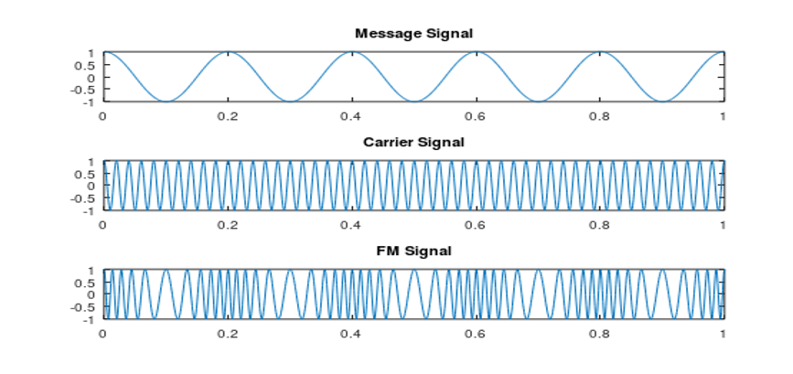

Result
The Frequency Modulated (FM) signal was successfully generated using MATLAB, and the time-domain waveforms of the message signal, carrier signal, and FM signal were observed and analyzed.

QUESTION 1
A local FM radio station plans to transmit an audio signal of frequency 1 kHz. The station uses a carrier frequency of 100 kHz and a frequency sensitivity of 5 kHz/V. The audio signal amplitude is 2 V.

Tasks
- Develop a MATLAB program to generate the message signal.
- Generate the corresponding FM signal.
- Plot the message and FM waveforms.
- Calculate the maximum frequency deviation.
- Determine the modulation index

Aim  (10) | Tabular Column/ Program  (20) | Procedure/Calculations  (20) | Results  (20) | Record  (10) | Viva  (20) | Total  (100)

QUESTION 2
A community radio station wants to estimate the bandwidth required for transmission. The station uses:
- Message frequency = 2 kHz
- Message amplitude = 3 V
- Carrier frequency = 75 kHz
- Frequency sensitivity = 3 kHz/V

Tasks
- Generate the FM signal.
- Calculate the maximum frequency deviation.
- Determine the modulation index.
- Calculate bandwidth using Carson's Rule.
- Plot the waveform.

Aim  (10) | Tabular Column/ Program  (20) | Procedure/Calculations  (20) | Results  (20) | Record  (10) | Viva  (20) | Total  (100)

Objective 2: To analyze the frequency spectrum of the generated FM signal using FFT and identify the carrier component, sideband frequencies, and the bandwidth of the FM signal based on Carson's rule

PROGRAM (MATLAB CODE)
% Calculation and Verification of Frequency Deviation
% and Modulation Index of FM Signals
clc;
clear;
close all;
%% Input Parameters
Am = 2; % Message signal amplitude
fm = 500; % Message frequency (Hz)
Ac = 1; % Carrier amplitude
fc = 10000; % Carrier frequency (Hz)
kf = 1000; % Frequency sensitivity (Hz/V)
fs = 100000; % Sampling frequency (Hz)
T = 0.02; % Simulation duration (s)
t = 0:1/fs:T;
%% Message Signal
m = Am*cos(2*pi*fm*t);
%% Frequency Deviation Calculation
delta_f = kf * Am;
%% Modulation Index Calculation
beta = delta_f/fm;
%% FM Signal Generation
fm_signal = Ac*cos(2*pi*fc*t + beta*sin(2*pi*fm*t));
%% Plot Message Signal
figure;
subplot(2,1,1);
plot(t,m,'LineWidth',1.5);
title('Message Signal');
xlabel('Time (s)');
ylabel('Amplitude');
grid on;
%% Plot FM Signal
subplot(2,1,2);
plot(t,fm_signal,'LineWidth',1.5);
title('Frequency Modulated Signal');
xlabel('Time (s)');
ylabel('Amplitude');
grid on;
%% Spectrum Analysis
N = length(fm_signal);
FM_fft = fftshift(abs(fft(fm_signal))/N);
f = (-N/2:N/2-1)*(fs/N);
figure;
plot(f,FM_fft,'LineWidth',1.5);
title('FM Signal Spectrum');
xlabel('Frequency (Hz)');
ylabel('Magnitude');
grid on;
xlim([fc-10000 fc+10000]);
%% Display Results
fprintf('\nFM SIGNAL PARAMETERS\n');
fprintf('---------------------------\n');
fprintf('Carrier Frequency = %.0f Hz\n',fc);
fprintf('Message Frequency = %.0f Hz\n',fm);
fprintf('Message Amplitude = %.2f V\n',Am);
fprintf('Frequency Sensitivity = %.0f Hz/V\n',kf);
fprintf('\nCALCULATED VALUES\n');
fprintf('---------------------------\n');
fprintf('Frequency Deviation (Δf) = %.0f Hz\n',delta_f);
fprintf('Modulation Index (β) = %.2f\n',beta);
%% Carson's Rule Bandwidth
BW = 2*(delta_f + fm);
fprintf('Bandwidth (Carson Rule) = %.0f Hz\n',BW);

Procedure
- Open MATLAB and create a new script file.
- Clear the command window, workspace variables, and close all existing figure windows using:
clc;
Clear;
close all;
- Define the message signal parameters:
- Message amplitude Am=2V
- Message frequency fm=500Hz
- Define the carrier signal parameters:
- Carrier amplitude Ac=1V
- Carrier frequency fc=10000Hz
- Set the frequency sensitivity constant kf=1000Hz/V, sampling frequency fs=100000Hz, and simulation duration T=0.02s.
- Generate the time vector using:
t = 0:1/fs:T;
- Generate the message signal using:
m = Am*cos(2*pi*fm*t);
- Calculate the frequency deviation of the FM signal using:
Δf=kf.Am
- Calculate the modulation index using:
β=Δf/f_m
- Generate the FM signal using:
fm_signal = Ac*cos(2*pi*fc*t + beta*sin(2*pi*fm*t));
- Plot the message signal in the time domain and observe its waveform.
- Plot the generated FM signal and observe that the carrier frequency varies according to the message signal while the amplitude remains constant.
- Determine the length of the FM signal:
N = length(fm_signal);
- Compute the Fast Fourier Transform (FFT) of the FM signal:
FM_fft = fft(fm_signal);
- Shift the spectrum to center the zero-frequency component and normalize it:
FM_fft = fftshift(abs(FM_fft)/N);
- Generate the frequency axis corresponding to the FFT output:
f = (-N/2:N/2-1)*(fs/N);
- Plot the frequency spectrum of the FM signal and observe the carrier component and sidebands.
- Restrict the frequency axis around the carrier frequency for better visualization:
xlim([fc-10000 fc+10000]);
- Calculate the bandwidth of the FM signal using Carson's Rule:
BW=2(Δf+f_m)
- Display the carrier frequency, message frequency, frequency deviation, modulation index, and bandwidth in the MATLAB command window.
- Execute the program and verify that the calculated frequency deviation and modulation index match the values used in generating the FM signal

OUTPUT
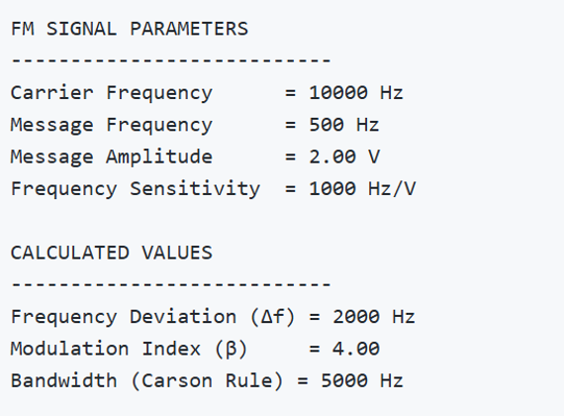

OUTPUT (GRAPH)

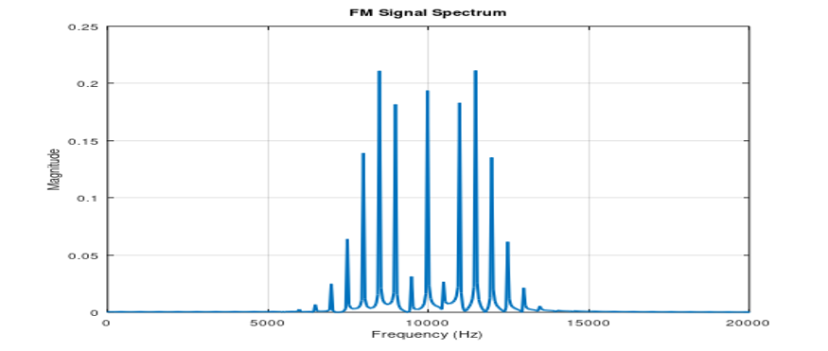

Example (Just for Understanding)
Given:
Message Amplitude A_m=2V
Message Frequency f_m=500Hz
Frequency Sensitivity k_f=1000Hz/V
Frequency deviation:
Δf=k_f A_m
Δf=1000×2=2000" Hz"

Modulation index:
β=Δf/f_m
β=2000/500=4

Bandwidth using Carson's Rule:
BW=2(Δf+f_m)=2(2000+500)=5000" Hz"

Result
i) The time-domain waveform was observed, and the frequency spectrum obtained using FFT has been plotted.
ii) Also, calculated the frequency deviation and bandwidth using Carson’s rule.

QUESTION 1
Generate an FM signal using MATLAB simulation for the given parameters
Carrier Frequency (fc) = 10 kHz
Message Frequency (fm) = 1 kHz
Modulation Index (β) = 2
Tasks:
- Plot the frequency spectrum of the FM signal using FFT.
- Identify the carrier frequency component.
- Locate the first-order sidebands.
- Calculate the frequency deviation and bandwidth using Carson's Rule.

Aim  (10) | Tabular Column/ Program  (20) | Procedure/ Calculations  (20) | Results  (20) | Record  (10) | Viva  (20) | Total  (100)

QUESTION 2

Generate an FM signal using MATLAB simulation for the given parameters
fc=20kHz
fm=2kHz
β=3
Tasks:
- Determine the frequencies of the first three upper sidebands.
- Determine the frequencies of the first three lower sidebands.
- Verify the sideband locations using the FFT spectrum.
- Comment on the spacing between adjacent sidebands.

Aim  (10) | Tabular Column/ Program  (20) | Procedure/ Calculations  (20) | Results  (20) | Record  (10) | Viva  (20) | Total  (100)

EX NO: 2b | CALCULATION AND VERIFICATION OF FREQUENCY DEVIATION AND MODULATION INDEX OF FM SIGNALS USING MATLAB SIMULATION
DATE:

Objectives:
To generate a Frequency Modulated (FM) signal in MATLAB using specified message and carrier signal parameters, and to determine the frequency deviation and modulation index of the FM signal while analyzing the relationship between frequency deviation, message frequency, and modulation index.

PROGRAM (MATLAB CODE)

% Calculation and Verification of Frequency Deviation
% and Modulation Index of FM Signal
clc;
clear;
close all;
%% Message Signal Parameters
Am = 2; % Message amplitude (V)
fm = 500; % Message frequency (Hz)
%% Carrier Signal Parameters
Ac = 1; % Carrier amplitude (V)
fc = 10000; % Carrier frequency (Hz)
%% FM Parameters
kf = 250; % Frequency sensitivity (Hz/V)
fs = 100000; % Sampling frequency (Hz)
T = 0.01; % Simulation duration (s)
%% Time Vector
t = 0:1/fs:T;
%% Message Signal
m = Am*cos(2*pi*fm*t);
%% Frequency Deviation
delta_f = kf*Am;
%% Modulation Index
beta = delta_f/fm;
%% FM Signal
fm_signal = Ac*cos(2*pi*fc*t + beta*sin(2*pi*fm*t));
%% Display Parameters
fprintf('Carrier Frequency (fc) = %.0f Hz\n',fc);
fprintf('Message Frequency (fm) = %.0f Hz\n',fm);
fprintf('Message Amplitude (Am) = %.0f V\n',Am);
fprintf('Frequency Sensitivity (kf) = %.0f Hz/V\n',kf);
fprintf('\nFrequency Deviation (Delta f) = %.2f Hz\n',delta_f);
fprintf('Modulation Index (Beta) = %.2f\n',beta);
%% Verification
beta_verify = delta_f/fm;
fprintf('Verified Modulation Index = %.2f\n',beta_verify);
%% Verification Check
tolerance = 1e-6;
if abs(beta - beta_verify) < tolerance
fprintf('\nVerification Successful\n');
else
fprintf('\nVerification Failed\n');
end
%% Plotting
figure;
subplot(2,1,1);
plot(t,m,'LineWidth',1.5);
grid on;
title('Message Signal');
xlabel('Time (s)');
ylabel('Amplitude (V)');
subplot(2,1,2);
plot(t,fm_signal,'LineWidth',1);
grid on;
title('FM Signal');
xlabel('Time (s)');
ylabel('Amplitude (V)');

Procedure

- Open MATLAB and create a new script file.
- Clear the command window, workspace variables, and close all previously opened figure windows using:
Clc;
Clear;
close all;
- Define the message signal parameters:
- Message amplitude A_m=2V
- Message frequency f_m=500Hz
- Define the carrier signal parameters:
- Carrier amplitude A_c=1V
- Carrier frequency f_c=10000Hz
- Define the frequency sensitivity constant k_f, sampling frequency f_s, and simulation duration T
- Generate the time vector using:
t = 0:1/fs:T;
- Generate the message signal using:
m = Am*cos(2*pi*fm*t);
and observe the sinusoidal waveform.
- Calculate the frequency deviation of the FM signal using:
Δf=kf. Am

- Calculate the modulation index using:
β=Δf/fm

- Generate the FM signal using:
fm_signal = Ac*cos(2*pi*fc*t + beta*sin(2*pi*fm*t));
where the carrier frequency varies according to the message signal.
- Plot the message signal in the first subplot and label the axes appropriately.
- Plot the FM signal in the second subplot and observe the variation in instantaneous frequency.
- Display the carrier frequency, message frequency, message amplitude, and frequency sensitivity in the MATLAB command window using fprintf statements.
- Display the calculated frequency deviation and modulation index values in the command window.
- Verify the modulation index by recomputing it using:
β=Δf/fm

and compare the result with the previously calculated value.
- Use a conditional statement (if-else) to check whether both modulation index values are equal within a small tolerance.
- Display the verification result as:
- "Verification Successful" if both values match.
- "Verification Failed" otherwise.
- Execute the MATLAB program and observe the message signal, FM signal, calculated frequency deviation, modulation index, and verification result.

OUTPUT
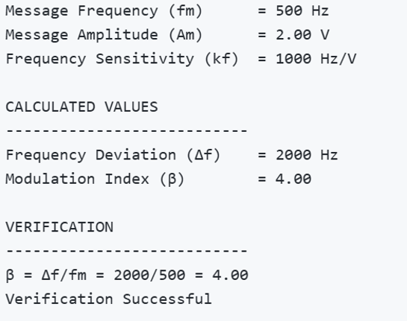

OUTPUT GRAPH
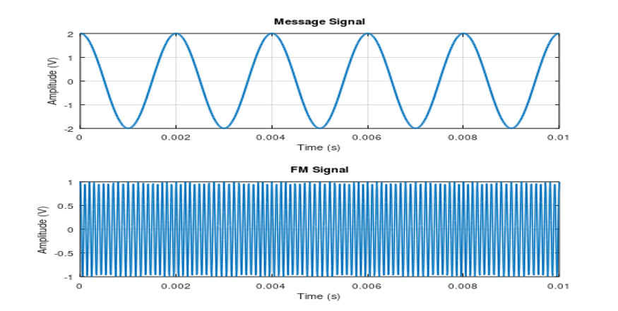

Example (Just for Understanding)

For:
A_m=2V
f_m=500Hz
k_f=1000Hz/V
Frequency deviation:
Δf=k_f A_m
Δf=1000×2=2000" Hz"

Modulation index:
β=Δf/f_m
β=2000/500=4

Result

This experiment verifies that the modulation index is equal to the ratio of frequency deviation to message frequency, i.e., β=Δf/f_m.

QUESTION 1
A communication engineer is testing an FM transmitter that will be used in a wireless voice communication system. During the design phase, the engineer needs to determine the maximum frequency deviation produced by the FM modulator to ensure that the transmitted signal remains within the allocated channel bandwidth.
The FM modulator is configured with the following parameters:
- Message Signal Amplitude (AmA_mAm​) = 2 V
- Frequency Sensitivity (kfk_fkf​) = 1000 Hz/V
The engineer must verify the theoretical frequency deviation and confirm the result through MATLAB simulation before deploying the system.

Tasks
- Calculate the theoretical maximum frequency deviation (Δf\Delta fΔf) of the FM signal.
- Develop a MATLAB program to generate the message signal and FM signal.
- Compute the frequency deviation using the given FM parameters.
- Display the calculated frequency deviation in the MATLAB Command Window.
- Plot the message signal and the corresponding FM signal in the time domain.
Aim  (10) | Tabular Column/ Program  (20) | Procedure/ Calculations  (20) | Results  (20) | Record  (10) | Viva  (20) | Total  (100)

QUESTION 2
A broadcast engineer is evaluating the performance of an FM transmitter before it is deployed in a local radio station. To ensure proper signal quality and bandwidth utilization, the engineer must determine the modulation index of the FM signal and verify the result through MATLAB simulation. During testing, the transmitter is found to produce a maximum frequency deviation of 2000 Hz when modulated by an audio signal of frequency 500 Hz. The engineer needs to calculate the modulation index and compare the theoretical value with the value obtained from the MATLAB-generated FM signal.

Given
- Frequency Deviation (Δf\Delta fΔf) = 2000 Hz
- Message Frequency (fmf_mfm​) = 500 Hz

Tasks
- Calculate the theoretical modulation index (β\betaβ) of the FM signal.
- Develop a MATLAB program to generate the corresponding FM signal.
- Determine the modulation index using the simulation parameters.
- Display the calculated modulation index in the MATLAB Command Window.
- Plot the message signal and FM signal in the time domain.

Aim  (10) | Tabular Column/ Program  (20) | Procedure/ Calculations  (20) | Results  (20) | Record  (10) | Viva  (20) | Total  (100)

EX NO: 3a | GENERATION OF PHASE MODULATED (PM) SIGNALS AND CALCULATION OF PHASE DEVIATION USING MATLAB SIMULATION
DATE:

Objectives:

i) To generate a Phase Modulated (PM) signal in MATLAB using specified carrier and message signal parameters.

ii) To observe and analyze the time-domain characteristics of the message signal, carrier signal, and phase modulated signal through MATLAB simulation.

iii) To calculate the phase deviation of the PM signal using the phase sensitivity constant and message signal amplitude.

iv) To determine the modulation index of the PM signal and examine its relationship with phase deviation.

v) To investigate the effect of varying message signal amplitude on the phase deviation and modulation characteristics of the PM signal.

vi) To compare PM waveforms obtained for different phase deviation values and analyze their modulation behavior using MATLAB.

PROGRAM (MATLAB CODE)
clc;
clear;
close all;
% Parameters
Am = 1; % Message Amplitude (V)
fm = 100; % Message Frequency (Hz)
Ac = 5; % Carrier Amplitude (V)
fc = 1000; % Carrier Frequency (Hz)
fs = 20*fc; % Sampling Frequency (Hz)
kp = pi/2; % Phase Sensitivity (rad/V)
% Time Vector
t = 0:1/fs:4/fm;
% Message Signal
m = Am*sin(2*pi*fm*t);
% Carrier Signal
c = Ac*cos(2*pi*fc*t);
% Phase Modulated Signal
pm = Ac*cos(2*pi*fc*t + kp*m);
% Phase Deviation
phase_dev = kp*Am;
% PM Modulation Index
mp = phase_dev;
% Display Results
fprintf('Message Amplitude = %.2f V\n',Am);
fprintf('Message Frequency = %.0f Hz\n',fm);
fprintf('Carrier Amplitude = %.2f V\n',Ac);
fprintf('Carrier Frequency = %.0f Hz\n',fc);
fprintf('Phase Sensitivity = %.2f rad/V\n',kp);
fprintf('Phase Deviation = %.2f radians\n',phase_dev);
fprintf('PM Modulation Index = %.2f\n',mp);
% Plotting
figure('Name','Phase Modulation and Phase Deviation',...
'NumberTitle','off');
subplot(2,2,1);
plot(t,m,'LineWidth',1.5);
title('Message Signal');
xlabel('Time (s)');
ylabel('Amplitude');
grid on;
subplot(2,2,2);
plot(t,c,'LineWidth',1.5);
title('Carrier Signal');
xlabel('Time (s)');
ylabel('Amplitude');
grid on;
subplot(2,2,3);
plot(t,pm,'LineWidth',1.5);
title('Phase Modulated Signal');
xlabel('Time (s)');
ylabel('Amplitude');
grid on;
subplot(2,2,4);
bar(phase_dev);
title('Phase Deviation');
ylabel('Radians');
set(gca,'XTickLabel',{'PM Signal'});
grid on;

Procedure:
- Open MATLAB and create a new script file.
- Initialize the MATLAB workspace by clearing all variables, command window contents, and open figure windows using:
MATLABclc; clear; close all;
- Define the message signal amplitude ( ), message frequency ( ), carrier amplitude ( ), carrier frequency ( ), sampling frequency ( ), and phase sensitivity constant ( ).
- Generate the time vector required for simulation using the specified sampling frequency.
- Generate the message signal using a sinusoidal waveform with frequency .
- Generate the carrier signal using a sinusoidal waveform with frequency .
- Generate the Phase Modulated (PM) signal
- Plot the message signal, carrier signal, and phase modulated signal using MATLAB plotting commands.
- Observe the phase variations in the PM waveform corresponding to changes in the message signal amplitude.
- Calculate the phase deviation of the PM signal
- Determine the PM modulation index from the calculated phase deviation.
- Display the values of phase deviation and modulation index in the MATLAB Command Window using the fprintf() function.
- Repeat the simulation for different message signal amplitudes and observe the corresponding change in phase deviation.
- Compare the generated PM waveforms for different phase deviation values.
- Record the observations and verify the relationship between message amplitude, phase deviation, and modulation index.
- Analyze the simulation results and validate the characteristics of Phase Modulation.

OUTPUT (GRAPH)
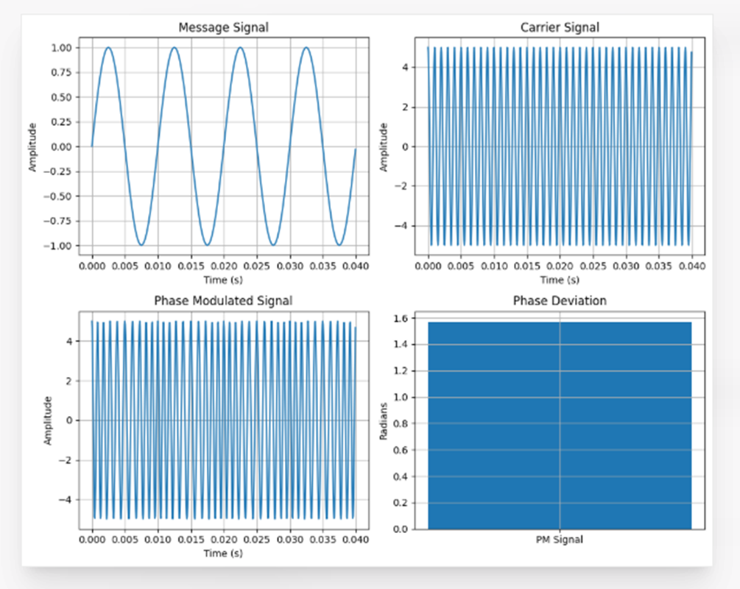
Example: (just for Understanding)
Calculations for Phase Deviation and Power Spectral Density of PM Signal
Given:
· Message Amplitude, V
· Message Frequency, Hz
· Carrier Amplitude, V
· Carrier Frequency, Hz
· Phase Sensitivity, rad/V = 1.57 rad/V

1. Phase Deviation
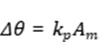

Substituting the values,
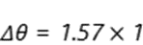


2. Modulation Index of PM Signal
For Phase Modulation,
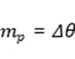
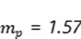

3. Estimated Bandwidth using Carson's Rule
For PM,
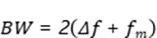
where
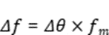
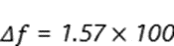
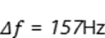
Therefore,
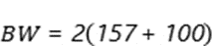
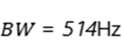

4. Carrier Power
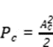
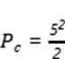
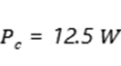

RESULT
The Phase Modulated (PM) signal was successfully generated and analyzed using MATLAB. The phase deviation was calculated from the phase sensitivity constant and message amplitude.
i) Message Frequency = 100 Hz
ii) Carrier Frequency = 1000 Hz
iii) Phase Sensitivity = 1.57 rad/V
iv) Phase Deviation = 1.57 radians
v) PM Modulation Index = 1.57
vi) The PM waveform exhibited phase variations proportional to the message signal amplitude, verifying the characteristics of Phase Modulation.

QUESTION 1
Imagine a communication system employs Phase Modulation (PM) with a carrier frequency of 1000 Hz and a message frequency of 100 Hz. The phase sensitivity constant is 1.57 rad/V. Calculate the phase deviation, modulation index, peak frequency deviation, and bandwidth for message amplitudes of 1 V, 2 V, and 3 V. Analyze the PM signal using MATLAB.
Tasks:
i) Generate the PM signal using the given carrier and message signal frequencies.
ii) Plot the message signal, carrier signal, and phase modulated signal.
iii) Calculate the phase deviation for each message amplitude.
iv) Determine the modulation index of the PM signal.
v) Calculate the peak frequency deviation.

Aim  (10) | Tabular Column/ Program  (20) | Procedure/Calculations  (20) | Results  (20) | Record  (10) | Viva  (20) | Total  (100)

QUESTION 2
A PM transmitter operates with a carrier frequency of 2000 Hz and a message frequency of 200 Hz. The message amplitude is maintained at 2 V while the phase sensitivity constant is varied as 0.5 rad/V, 1 rad/V, and 1.5 rad/V. Determine the phase deviation, modulation index, peak frequency deviation, and bandwidth for each case using MATLAB simulation.
Tasks:
i) Generate the PM signal for each phase sensitivity value.
ii) Plot the message signal, carrier signal, and PM waveform.
iii) Calculate the phase deviation for each case.
iv) Determine the PM modulation index.
v) Calculate the peak frequency deviation.

Aim  (10) | Tabular Column/ Program  (20) | Procedure/Calculations  (20) | Results  (20) | Record  (10) | Viva  (20) | Total  (100)

EX NO: 3b | POWER SPECTRAL DENSITY (PSD) ANALYSIS OF PHASE MODULATED (PM) SIGNALS USING MATLAB
DATE:

Objectives
i) To generate a Phase Modulated (PM) signal in MATLAB using specified carrier and message signal parameters.
ii) To compute the frequency spectrum of the PM signal using the Fast Fourier Transform (FFT).
iii) To calculate and plot the Power Spectral Density (PSD) of the PM signal using MATLAB.
iv) To identify the carrier component and sideband frequencies present in the PM spectrum.
v) To analyze the effect of phase modulation on the spectral distribution and bandwidth of the transmitted signal.
vi)To investigate the influence of modulation index on the Power Spectral Density characteristics of the PM signal.
PROGRAM (MATLAB CODE)
clc;
clear;
close all;
% Parameters
Am = 1; % Message Amplitude (V)
fm = 100; % Message Frequency (Hz)
Ac = 5; % Carrier Amplitude (V)
fc = 1000; % Carrier Frequency (Hz)
fs = 20*fc; % Sampling Frequency (Hz)
kp = pi/2; % Phase Sensitivity (rad/V)
% Time Vector
t = 0:1/fs:4/fm;
% Message Signal
m = Am*sin(2*pi*fm*t);
% PM Signal
pm = Ac*cos(2*pi*fc*t + kp*m);
% Phase Deviation
beta = kp*Am;
% FFT
N = length(pm);
f = linspace(-fs/2,fs/2,N);
PM_FFT = abs(fftshift(fft(pm)))/N;
% Power Spectral Density
PSD = (abs(fftshift(fft(pm))).^2)/(N*fs);
% Approximate Bandwidth
BW = 2*(beta+1)*fm;
fprintf('Phase Deviation = %.2f radians\n',beta);
fprintf('Estimated Bandwidth = %.2f Hz\n',BW);
% Plotting
figure('Name','PSD Analysis of PM Signal','NumberTitle','off');
subplot(2,2,1);
plot(t,m);
title('Message Signal');
xlabel('Time (s)');
ylabel('Amplitude');
grid on;
subplot(2,2,2);
plot(t,pm);
title('Phase Modulated Signal');
xlabel('Time (s)');
ylabel('Amplitude');
grid on;
subplot(2,2,3);
plot(f,PM_FFT);
title('Frequency Spectrum of PM Signal');
xlabel('Frequency (Hz)');
ylabel('Magnitude');
grid on;
subplot(2,2,4);
plot(f,PSD);
title('Power Spectral Density');
xlabel('Frequency (Hz)');
ylabel('PSD');
grid on;
Procedure:
- Open MATLAB and create a new script file.
- Initialize the MATLAB workspace by clearing all variables, command window contents, and open figure windows using:
clc; clear; close all;
- Define the message signal amplitude (AmA_mAm​), message frequency (fmf_mfm​), carrier amplitude (AcA_cAc​), carrier frequency (fcf_cfc​), sampling frequency (fsf_sfs​), and phase sensitivity constant (kpk_pkp​).
- Generate the time vector required for simulation.
- Generate the message signal and carrier signal.
- Generate the Phase Modulated (PM) signal using the PM equation.
- Compute the Fast Fourier Transform (FFT) of the PM signal.
- Calculate the Power Spectral Density (PSD) from the FFT results.
- Generate the frequency axis corresponding to the FFT output.
- Plot the message signal, PM signal, frequency spectrum, and PSD using MATLAB plotting commands.
- Determine the carrier frequency component and sideband frequencies from the spectrum.
- Display the phase deviation and estimated bandwidth using the MATLAB Command Window.
- Analyze the PSD plot and observe the spectral distribution around the carrier frequency.
- Record the observations and verify the characteristics of Phase Modulation in the frequency domain.
OUTPUT (GRAPH)
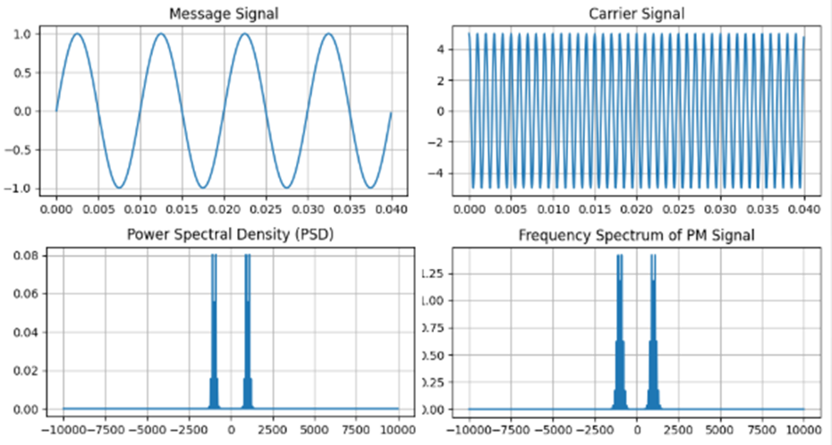
Example: (just for Understanding)
Given
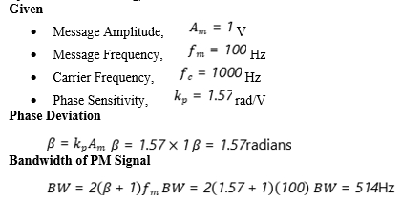
·

RESULT
The Power Spectral Density (PSD) of the Phase Modulated (PM) signal was successfully obtained and analyzed using MATLAB.
i) Message Frequency = 100 Hz
ii) Carrier Frequency = 1000 Hz
iii) Phase Deviation = 1.57 radians
iv) PM Modulation Index = 1.57
v) Estimated Bandwidth = 514 Hz
vi) The PSD plot showed the carrier component and multiple sidebands around the carrier frequency, confirming the frequency-domain characteristics of Phase Modulation.

QUESTION 1
A communication system employs Phase Modulation (PM) with a carrier frequency of 1000 Hz and a message frequency of 100 Hz. The message signal amplitude is 1 V, the carrier amplitude is 5 V, and the phase sensitivity constant is 1.57 rad/V. Analyze the frequency spectrum and Power Spectral Density (PSD) of the generated PM signal using MATLAB.
Tasks:
- Generate the PM signal using the given carrier and message signal parameters.
- Plot the message signal and PM signal.
- Compute the Fast Fourier Transform (FFT) of the PM signal.
- Plot the frequency spectrum of the PM signal.
- Calculate and plot the Power Spectral Density (PSD).

Aim  (10) | Tabular Column/ Program  (20) | Procedure/Calculations  (20) | Results  (20) | Record  (10) | Viva  (20) | Total  (100)

QUESTION 2
A PM transmitter operates with a carrier frequency of 2000 Hz and a message frequency of 200 Hz. The carrier amplitude is 10 V, the message amplitude is 2 V, and the phase sensitivity constant is 1 rad/V. Generate the PM signal and investigate its spectral characteristics through PSD analysis using MATLAB.
Tasks:
- Generate the PM signal using the specified parameters.
- Plot the message signal and PM signal.
- Compute the FFT of the PM signal.
- Plot the frequency spectrum showing the carrier and sidebands.
- Calculate and plot the Power Spectral Density (PSD).

Aim  (10) | Tabular Column/ Program  (20) | Procedure/Calculations  (20) | Results  (20) | Record  (10) | Viva  (20) | Total  (100)

EX NO: 4 | GENERATION, SAMPLING, AND RECONSTRUCTION OF SIGNALS USING SAMPLING AND RECONSTRUCTION TRAINER KIT
DATE:

Objectives

i) To understand the process of sampling and reconstruction of analog signals using the signal sampling trainer kit.

Procedure
- Connect the signal sampling trainer kit as shown in the block diagram.
- Switch ON the trainer kit and verify the power supply connections.
- Apply a sinusoidal analog signal as the input to the sampling circuit.
- Apply a clock signal to the sampler circuit to perform the sampling operation.
- Observe the input analog signal on the Digital Storage Oscilloscope (DSO) and record its amplitude and frequency.
- Observe the sampled output waveform at the output of the sampler circuit using the DSO.
- Verify that the sampled signal consists of discrete samples of the original analog signal.
- Apply the sampled signal to the reconstruction filter circuit.
- Observe the reconstructed output waveform on the DSO.
- Compare the reconstructed signal with the original input signal and verify that the original waveform is recovered.
- Record the observations and analyze the sampling and reconstruction process.

BLOCK DIAGRAM

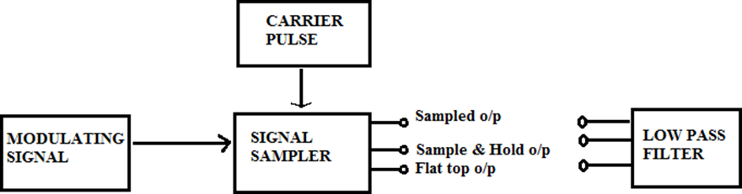

MODEL GRAPH:
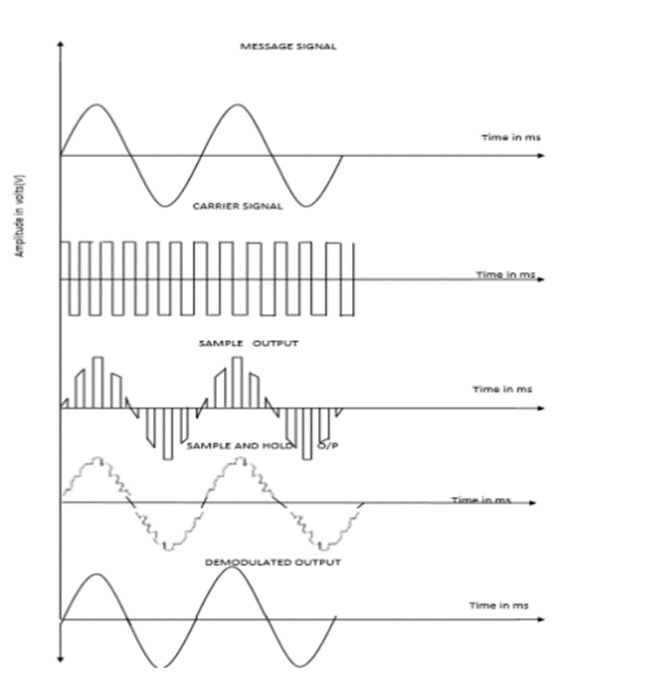

Tabular Column
S.No | Name of the signal | Amplitude in V | Time period in Sec | Frequency in Hz
1 | Modulating Signal
2 | Carrier Signal
3 | Modulated output
4 | Demodulated output

Example :( Just for understanding)
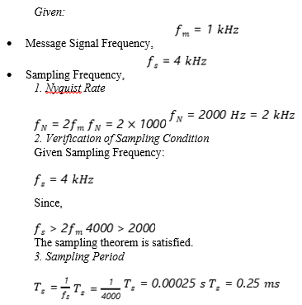

Result

Thus the signal is sampled and reconstructed by using signal sampling trainer kit and the output waveform is obtained.

QUESTION 1
A communication system transmits a sinusoidal signal of frequency 1 kHz. The signal is sampled at a frequency of 4 kHz using a signal sampling trainer kit. Observe the sampled waveform and reconstruct the original signal using a reconstruction filter. Verify whether the sampling frequency satisfies the Nyquist criterion and analyze the reconstructed output.
Given:
Input Signal Frequency = 1 kHz
Sampling Frequency = 4 kHz
Tasks:
1. Apply the input signal to the sampler circuit.
2. Set the sampling frequency to 4 kHz.
3. Observe and plot the input signal waveform.
4. Observe and plot the sampled output waveform.
5. Calculate the Nyquist rate of the input signal.
6. Verify whether the sampling frequency satisfies the Nyquist criterion.
7. Reconstruct the sampled signal using the reconstruction filter.

Aim  (10) | Tabular Column/ Program  (20) | Procedure/Calculations  (20) | Results  (20) | Record  (10) | Viva  (20) | Total  (100)

QUESTION 2
A sinusoidal signal of frequency 2 kHz is applied to a signal sampling trainer kit. The signal is sampled at a frequency of 3 kHz and then reconstructed using a reconstruction filter. Analyze the effect of sampling below the Nyquist rate and observe the reconstructed output waveform.
Given:
Input Signal Frequency = 2 kHz
Sampling Frequency = 3 kHz
Tasks:
1. Apply the input signal to the sampler circuit.
2. Set the sampling frequency to 3 kHz.
3. Observe and plot the input signal waveform.
4. Observe and plot the sampled waveform.
5. Calculate the Nyquist rate of the input signal.
6. Compare the sampling frequency with the Nyquist rate.
7. Reconstruct the sampled signal using the reconstruction filter.
8. Observe any distortion or aliasing in the reconstructed signal.
9. Measure and record the amplitude, time period, and frequency of the waveforms.
Aim  (10) | Tabular Column/ Program  (20) | Procedure/Calculations  (20) | Results  (20) | Record  (10) | Viva  (20) | Total  (100)

EX NO: 5a | GENERATION AND DECODING OF PULSE CODE MODULATION (PCM) SIGNALS USING A PCM TRAINER KIT
DATE:

Objective:
To analyze and verify the different stages of PCM communication, including sampling, quantization, encoding, decoding, and signal reconstruction, by observing the corresponding waveforms at various test points of the PCM Trainer Kit.
Procedure
- Power on the PCM kit.
2. Measure the frequency of the sampling clock.
3. Apply the DC voltage as a modulating signal.
4. Connect the DC input to the ADC and measure the voltage.
5. Connect the clock to the timing and control circuit.
6. Note the binary work from the LED display. The serial data through the channel can be observed in the DSO.
7. Also observe the binary word at the receiver end.
8. Now apply the AC modulating signal at the input.
9. Observe the waveform at the output of DAC.
10. Note the amplitude of the input voltage and the code word. Also note the value of the output voltage. Show the code word graphically for a DC input.
Block Diagram

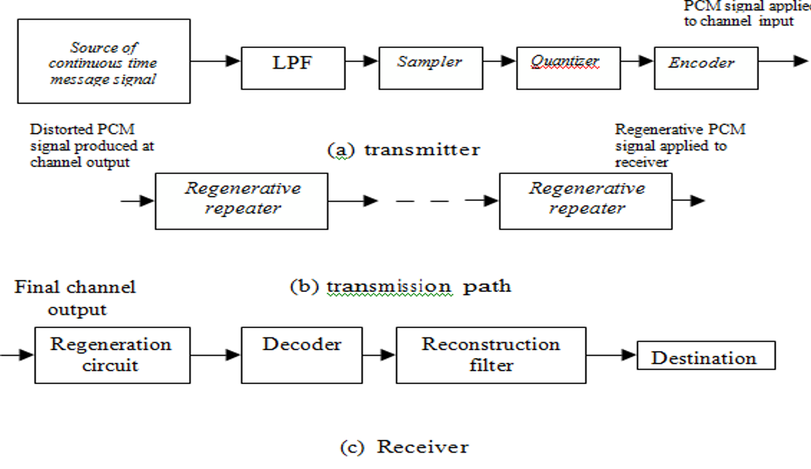

MODEL GRAPH
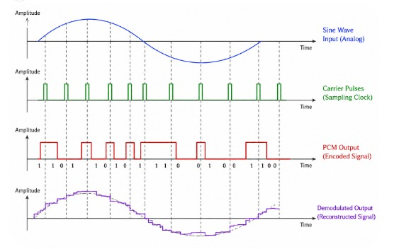

Tabular Column:

 | S.No | Name of the signal | Amplitude in Volts | Time period in Sec | Frequency in Hz
 | 1 | Modulating Signal
 | 2 | Carrier Signal
 | 3 | Modulated Signal
 | 4 | Demodulated Signal

Example (just for understanding)
Suppose in your PCM Trainer Kit experiment:
- Input analog signal: 1 kHz sine wave
- Sampling frequency: 8 kHz
- Quantization levels: 16 levels (4-bit PCM)
- You observed the waveforms at different test points:
  - Sampling output → sampled sine wave
  - Quantizer output → staircase waveform
  - Encoder output → binary PCM pulses
  - Decoder output → recovered staircase signal
  - Reconstruction filter output → recovered sine wave

Result:
The stages of PCM communication were successfully verified using the PCM Trainer Kit, and the original analog signal was accurately reconstructed from the decoded PCM signal.
QUESTION 1
A temperature monitoring system converts analog sensor signals into digital form before transmission. A low-frequency analog signal is applied to the PCM Trainer Kit. Perform the following:
- Generate the PCM signal.
- Observe the quantized output.
- Determine the number of quantization levels used.
- Observe the encoded binary sequence.
- Decode the PCM signal and reconstruct the original signal.

Aim  (10) | Tabular Column/ Program  (20) | Procedure/Calculations  (20) | Results  (20) | Record  (10) | Viva  (20) | Total  (100)

QUESTION 2
A telecommunications company is upgrading its analog communication system to a PCM-based digital communication system. Before deployment, the engineer must verify the complete PCM generation and decoding process. Using the PCM Trainer Kit and a 1 kHz sinusoidal input signal, perform the following:
- Generate the PCM signal by observing:
  - Sampling stage
  - Quantization stage
  - Encoding stage
- Observe and sketch the waveform at each stage.
- Decode the PCM signal.
- Reconstruct the original analog signal using the reconstruction filter.

Aim  (10) | Tabular Column/ Program  (20) | Procedure/Calculations  (20) | Results  (20) | Record  (10) | Viva  (20) | Total  (100)
EX NO: 5b | TO GENERATE AND ANALYZE DELTA MODULATION (DM) SIGNALS USING A DM TRAINER KIT
DATE:

Objective:
i) To generate and analyze a Delta Modulated (DM) signal using a DM Trainer Kit by observing the encoding and reconstruction processes.

Procedure:
- Power ON the DM kit.
- Measure the frequency of the sampling clock.
- Apply the DC voltage as a modulating signal.
- Connect the DC input to the ADC and measure the voltage.
- Connect the clock to the timing and control circuit.
- Note the binary work from the LED display. The serial data through the channel can be observed in the DSO.
- Also observe the binary word at the receiver end.
- Now apply the ac modulating signal at the input.
- Observe the waveform at the output of the digital to analog converter.
- Note the amplitude of the input signal and the codeword. Also note the value of the output voltage. Show the codeword graphically for a DC input.
Block Diagram:
Delta Modulator
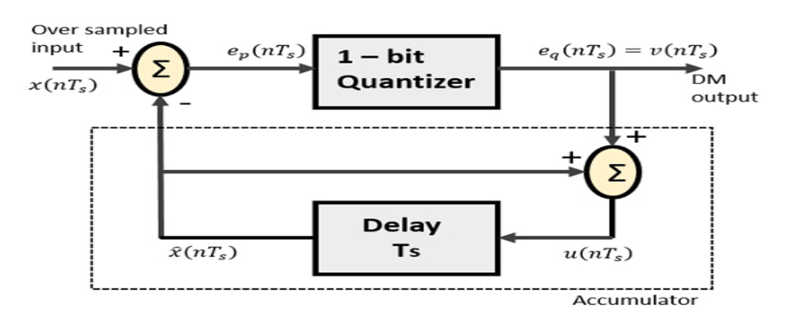
Delta Demodulator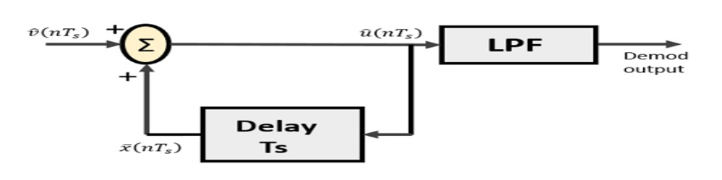

Model Graph
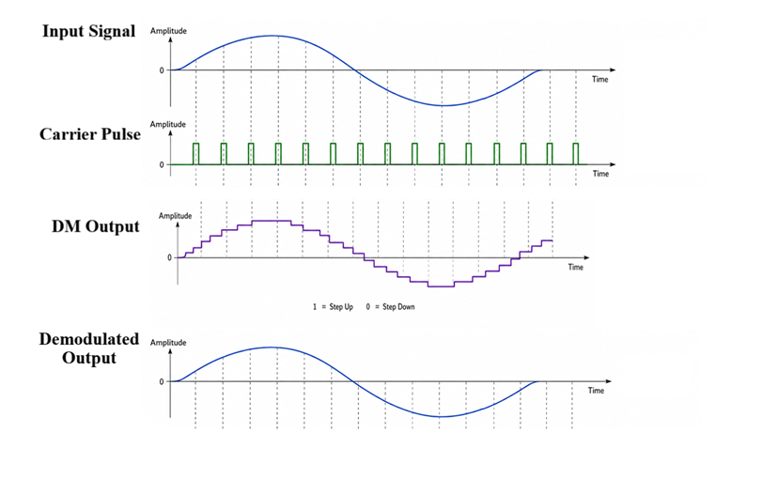
Tabular Column

Sl. No. | Name of the signal | Amplitude in V | Time period in Sec | Frequency in Hz
1
2
3
4

Example (just for understanding)
Suppose a 1 kHz sine wave is applied as the input signal to the DM Trainer Kit.

1. Input Signal
- A 1 kHz sinusoidal waveform is fed to the modulator.
- This signal is displayed on the CRO/DSO.

2. DM Encoding Process
- The DM encoder compares the input signal with the staircase approximation.
- If the input is greater than the staircase signal, a binary 1 is generated.
- If the input is less than the staircase signal, a binary 0 is generated.
- Thus, a stream of 1s and 0s forms the DM output signal.

3. Staircase Approximation
- The staircase waveform attempts to follow the input sine wave.
- Each "1" causes the staircase to move up by one step.
- Each "0" causes the staircase to move down by one step.

4. DM Output
Example binary sequence observed:
1110011011001110...
This sequence represents the Delta Modulated signal.

5. Demodulation (Reconstruction)
- The DM signal is passed through the decoder and reconstruction filter.
- The recovered output waveform resembles the original 1 kHz sine wave.

6. Observation of Distortions

Case A: Slope Overload Distortion
- Increase the input frequency to 5 kHz while keeping the step size fixed.
- The staircase waveform cannot follow the rapid changes of the input signal.
- The reconstructed signal becomes distorted.
Observation: Slope overload distortion is present.
Result
i) The Delta Modulated (DM) signal was successfully generated, analyzed, the encoding and reconstruction processes were verified by observing the input signal, staircase approximation signal, DM output, and reconstructed signal using the DM Trainer Kit.

QUESTION 1
A company developing a low-cost digital communication system intends to use Delta Modulation (DM) for transmitting analog signals from remote monitoring stations. Before implementation, the performance of the DM system must be evaluated using a DM Trainer Kit. As a communication engineer, you are required to generate and analyze a Delta Modulated signal for a given analog input signal. Observe the input signal, staircase approximation signal, DM output signal, and reconstructed output signal at the corresponding test points of the trainer kit.
Tasks:
- Apply the given analog input signal to the DM Trainer Kit.
- Observe and sketch the input signal waveform.
- Observe and sketch the staircase approximation signal.
- Observe and record the DM output bit stream.
- Observe and sketch the reconstructed output signal.
Aim  (10) | Tabular Column/ Program  (20) | Procedure/Calculations  (20) | Results  (20) | Record  (10) | Viva  (20) | Total  (100)
QUESTION 2
A biomedical instrumentation company is designing a digital patient-monitoring system to transmit physiological signals from a patient monitoring unit to a central observation station. To reduce system complexity and bandwidth requirements, the company plans to use Delta Modulation (DM) for signal transmission. Before deployment, the communication subsystem must be tested using a DM Trainer Kit. As a communication engineer, you are required to evaluate the performance of the DM system by applying a sinusoidal analog signal to the trainer kit and observing the various stages of modulation and demodulation. Analyze the input signal, staircase approximation signal, DM output signal, and reconstructed output signal.
Tasks:
- Apply the specified sinusoidal input signal to the DM Trainer Kit.
- Observe and sketch the input waveform.
- Observe and sketch the staircase approximation waveform.
- Observe and record the Delta Modulated output signal.
- Demodulate the DM signal and observe the reconstructed output waveform.
Aim  (10) | Tabular Column/ Program  (20) | Procedure/Calculations  (20) | Results  (20) | Record  (10) | Viva  (20) | Total  (100)

EX NO: 6.a. | GENERATION AND DETECTION OF AMPLITUDE SHIFT KEYING (ASK) SIGNALS USING A DIGITAL COMMUNICATION TRAINER KIT
DATE:

Objectives
- Generate an Amplitude Shift Keying (ASK) signal by modulating a digital binary data sequence with a sinusoidal carrier and demodulate the ASK signal to recover the original binary data.
Procedure
- Connect the ASK generation circuit as per the trainer kit manual.
- Switch ON the trainer kit.
- Select the binary data source from the trainer.
- Set the carrier frequency to the specified value.
- Apply the binary data signal to the modulator input.
- Observe the binary data signal on Channel-1 of the DSO.
- Observe the carrier signal on Channel-2.
- Observe the ASK output waveform.
- Connect the ASK output to the demodulator input.
- Observe the recovered output signal using the DSO.
- Compare the recovered data with the original binary data.
- Measure the output amplitude and frequency.
- Record the observations.
- Sketch or capture the waveforms.
Block diagram
ASK Modulator
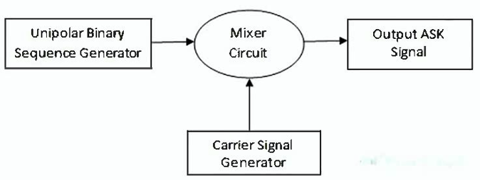

ASK Demodulator
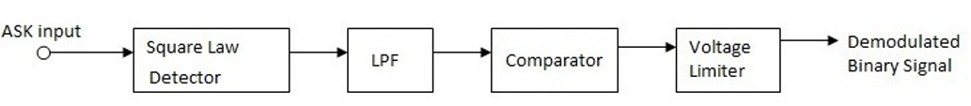

Model Waveforms
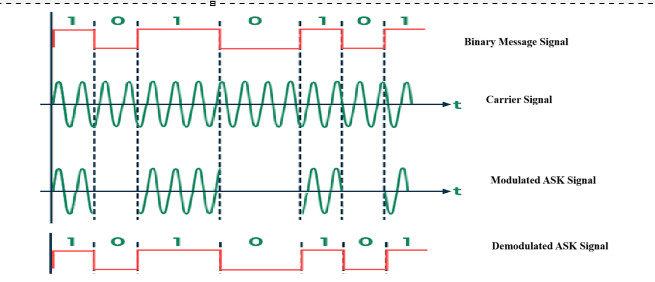
Tabular Column

Waveform | Amplitude (V) | Time Period (ms) | Frequency (Hz)
Binary Data Signal
Carrier Signal
ASK Signal
Demodulated Output

Example (Just for Understanding)
Given:
- Binary data sequence: 10110010
- Carrier amplitude: 5 V
- Carrier frequency: 10 kHz
- Bit duration: 1 ms
- ASK scheme:
  - Binary 1 → Carrier transmitted with amplitude 5 V
  - Binary 0 → No carrier transmitted (0 V)
Observation:
- The ASK modulator generated a waveform in which carrier bursts appeared during the bit intervals corresponding to 1s and disappeared during the bit intervals corresponding to 0s.
- After demodulation, the recovered binary sequence was:
101100101011001010110010
which is identical to the transmitted sequence.

Result:
The ASK signal was successfully generated and demodulated, and the recovered binary data matched the transmitted data sequence, confirming successful digital communication using ASK.

Question 1
In the laboratory, generate an Amplitude Shift Keying (ASK) signal using a carrier frequency of 100 kHz and a binary data sequence of 10110010. Observe and plot the binary data signal, carrier signal and ASK waveform. Demodulate the ASK signal and verify the recovered binary data.

Case 1
- Carrier Frequency, fc=100f_c = 100fc​=100 kHz
- Binary Data Sequence = 10110010
- Carrier Amplitude = 5 V
Expected Recovered Data:
10110010

Case 2
- Carrier Frequency, fc=100f_c = 100fc​=100 kHz
- Binary Data Sequence = 11001100
- Carrier Amplitude = 5 V
Expected Recovered Data:
11001100

Tasks
- Generate the ASK signal using the given binary sequence.
- Observe and plot the binary data signal.
- Observe and plot the carrier signal.
- Observe and plot the ASK signal.
- Demodulate the ASK signal.
- Compare the transmitted and recovered data signals.

Aim (10) | Tabular Column/ Program (20) | Procedure/Calculations (20) | Results (20) | Record (10) | Viva (20) | Total (100)

Question 2
In the laboratory, generate an ASK signal using a carrier frequency of 200 kHz and a binary data sequence of 11001100. Observe the ASK waveform and recover the original binary data through demodulation.

Case 1
- Carrier Frequency, fcf_cfc​ = 200 kHz
- Binary Data Sequence = 11001100

Case 2
- Carrier Frequency, fcf_cfc​ = 200 kHz
- Binary Data Sequence = 10101010

EX NO: 6.b. | GENERATION AND DETECTION OF FREQUENCY SHIFT KEYING (FSK) SIGNALS USING A DIGITAL COMMUNICATION TRAINER KIT
DATE:

Objectives
To study the generation and detection of Frequency Shift Keying (FSK) signals using a Digital Communication Trainer Kit and verify the accurate transmission and recovery of digital information.

Procedure
1. Connect the FSK generation circuit as per the trainer kit manual.
2. Switch ON the trainer kit.
3. Select the binary data source.
4. Set mark frequency (binary 1) and space frequency (binary 0).
5. Apply the binary data signal to the modulator input.
6. Observe binary data, carrier frequencies and FSK output using DSO.
7. Observe the received FSK signal.
8. Observe the recovered binary data using DSO.
9. Compare transmitted and recovered data.
10. Record amplitudes and frequencies.
11. Sketch or capture the waveforms.

Block Diagram

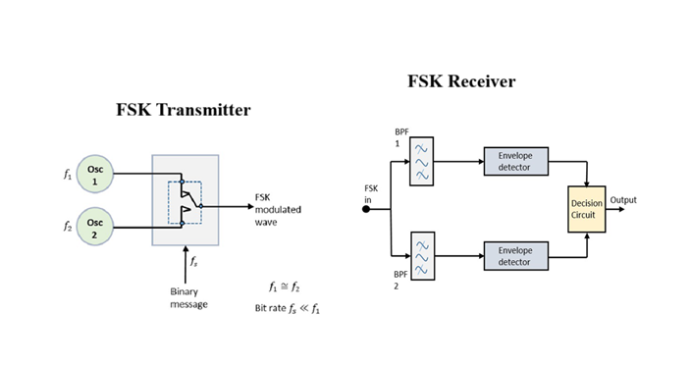

Model Graph

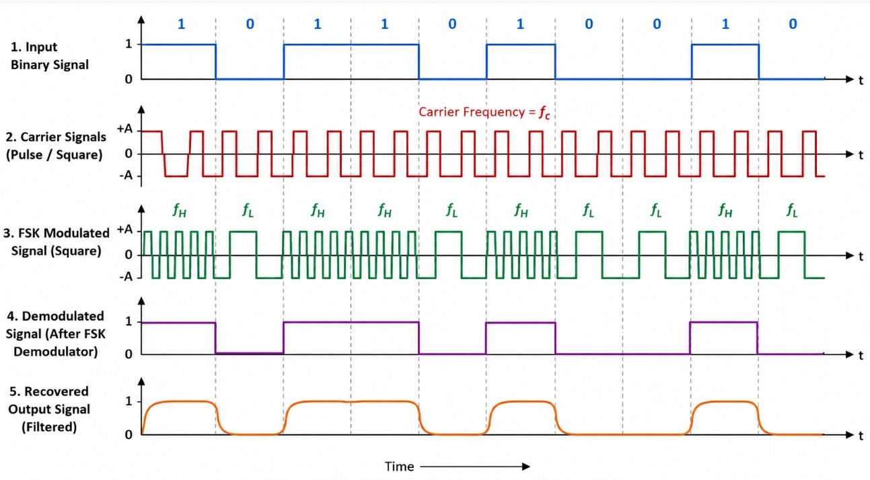

Tabular Column

Waveform | Amplitude (V) | Time Period (ms) | Frequency (Hz)
Binary Data Signal
Carrier Signal
FSK Signal
Demodulated Output

Example(Just for Understanding)
Given:
- Binary data sequence: 10110010
- Frequency for binary 1 (f1f_1f1​) = 5 kHz
- Frequency for binary 0 (f0f_0f0​) = 2 kHz
- Bit duration = 1 ms
- Modulation technique: Binary Frequency Shift Keying (BFSK)

FSK Signal Generation:
- When the input bit is 1, a 5 kHz carrier is transmitted.
- When the input bit is 0, a 2 kHz carrier is transmitted.
Thus, the FSK signal consists of alternating 5 kHz and 2 kHz carrier frequencies according to the input binary sequence 10110010.
Demodulation Observation:
- The FSK detector identifies the received frequencies.
- 5 kHz is decoded as 1.
- 2 kHz is decoded as 0.
Recovered Binary Sequence:10110010, which is identical to the transmitted sequence.
Result:
The generation and detection of the FSK signal were successfully carried out using the Digital Communication Trainer Kit, and the recovered binary data matched the transmitted data, verifying accurate digital communication through FSK.

Question 1
Generate an FSK signal using mark frequency = 100 kHz, space frequency = 50 kHz and binary sequence 10110010. Observe and plot the waveforms and verify the recovered data.
Case 1:
- Mark Frequency = 100 kHz
- Space Frequency = 50 kHz
- Binary Data = 10110010
- Expected Recovered Data = 10110010
Case 2:
- Mark Frequency (Binary 1) = 150 kHz
- Space Frequency (Binary 0) = 75 kHz
- Binary Data Sequence = 11001010
- Expected Recovered Data = 11001010
Tasks:
1. Generate FSK signal
2. Observe binary data signal
3. Observe FSK waveform
4. Demodulate FSK signal
5. Compare transmitted and recovered data

Aim (10) | Tabular Column/ Program (20) | Procedure/Calculations (20) | Results (20) | Record (10) | Viva (20) | Total (100)

Question 2
Generate an FSK signal using mark frequency = 200 kHz, space frequency = 100 kHz and binary sequence 11001100. Observe the waveform and recover the original data.

Case 1:
• Mark Frequency = 200 kHz
• Space Frequency = 100 kHz
• Binary Data = 11001100

Case 2:
- Mark Frequency = 300 kHz
- Space Frequency = 150 kHz
- Binary Data = 10001000

Tasks:
1. Generate FSK signal
2. Observe binary data signal
3. Observe FSK waveform
4. Demodulate FSK signal
5. Compare transmitted and recovered data

Aim (10) | Tabular Column/ Program (20) | Procedure/Calculations (20) | Results (20) | Record (10) | Viva (20) | Total (100)

EX NO: 6.c. | GENERATION AND DETECTION OF PHASE SHIFT KEYING (PSK) SIGNALS USING A DIGITAL COMMUNICATION TRAINER KIT
DATE:

Objectives:
To generate a Phase Shift Keying (PSK) signal by modulating a digital binary data sequence through phase variations of a carrier signal and to detect (demodulate) the PSK signal using a Digital Communication Trainer Kit for accurate recovery of the original binary data.

Procedure:
- Switch ON the experimental board.
- Apply the carrier signal to the input of the modulator
- Apply the modulating data signal to the modulator input and observe this signal on channel 1 of the DSO.
- Observe the output of the PSK modulator on the channel 2 of the DSO
- Apply this PSK output to the demodulator input and also apply the carrier input.
- Observe the Demodulator output and compare it with the modulating data signal applied to the modulator input which is identical.

Block Diagram
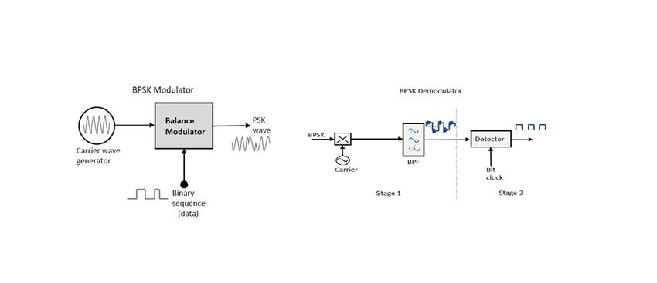

Model Waveforms
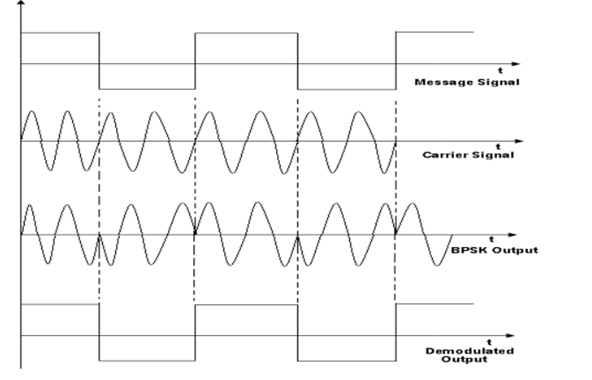

Tabular Column

Waveform | Amplitude (V) | Time Period (ms) | Frequency (Hz)
Binary Data Signal
Carrier Signal
PSK Signal
Demodulated Output

Example (Just for Understanding)
Given:
- Binary data sequence: 10110010
- Carrier frequency (fc​) = 10 kHz
- Carrier amplitude = 5 V
- Bit duration = 1 ms
- Modulation technique: Binary Phase Shift Keying (BPSK)
BPSK Encoding Rule:
- Binary 1 → Carrier phase = 0°
- Binary 0 → Carrier phase = 180°

Result:
The PSK signal was successfully generated and demodulated using the Digital Communication Trainer Kit. The recovered binary sequence was identical to the transmitted sequence, verifying reliable digital communication using PSK.

Question 1
Generate a PSK signal using carrier frequency 100 kHz and binary sequence 10110010. Observe PSK waveform and verify recovered data.
Case 1: fc = 100 kHz, Data = 10110010, Carrier Amplitude = 5V
- Expected Recovered Data: 10110010
Case 2: fc = 100 kHz, Data = 11001100, Carrier Amplitude = 5V
- Expected Recovered Data: 11001100

Tasks
- Generate PSK signal
- Plot binary data
- Plot carrier
- Plot PSK waveform
- Demodulate PSK signal
- Compare transmitted and recovered data
Aim (10) | Tabular Column/ Program (20) | Procedure/Calculations (20) | Results (20) | Record (10) | Viva (20) | Total (100)

Question 2
Generate a PSK signal using carrier frequency 200 kHz and binary sequence 11001100. Observe waveform and recover original binary data.
Case 1: fc = 200 kHz, Data = 11001100
Case 2: fc = 200 kHz, Data = 10101010
Tasks
- Generate PSK signal
- Plot binary data
- Plot carrier
- Plot PSK waveform
- Demodulate PSK signal
- Compare transmitted and recovered data

Aim (10) | Tabular Column (20) | Procedure/Calculations (20) | Results (20) | Record (10) | Viva (20) | Total (100)

EX NO: 7 | GENERATION AND ANALYSIS OF TIME DIVISION MULTIPLEXED SIGNALS USING A DIGITAL COMMUNICATION TRAINER KIT
Objectives
(i) To multiplex two input signals of different frequencies using the Time Division Multiplexing (TDM) technique and observe the composite TDM output signal.
(ii) To demultiplex the received TDM signal, recover the original input signals, and compare the frequencies of the recovered signals with the transmitted signals.
Block diagram
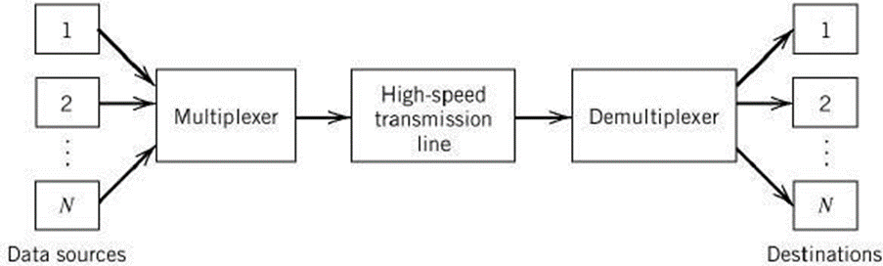
Model graph:

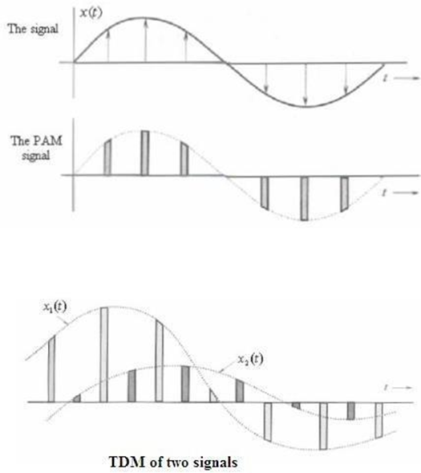

Test Signals
CH0 = 250 Hz
CH1 = 500 Hz
Objective 1:
To multiplex two input signals of different frequencies using the TDM technique and observe the composite output signal.
Procedure
- Switch ON the TDM trainer kit.
- Connect the 250 Hz sine wave to Channel CH0.
- Connect the 500 Hz sine wave to Channel CH1.
- Connect TXD of the transmitter to RXD of the receiver.
- Connect TXCLK to RXCLK.
- Connect TXSYNC to RXSYNC.
- Set the required amplitudes for all input signals.
- Observe the multiplexed output waveform using the DSO.
- Record the observations.
Tabulation
Signal | Amplitude (V) | Frequency (Hz)
CH0 Input |  | 250
CH1 Input |  | 500
TDM Output |  | Composite
Result
The two input signals were successfully multiplexed into a single composite TDM signal. The multiplexed waveform contained samples from all four channels occupying different time slots.
Objective 2:
To demultiplex the received TDM signal and verify the recovery of the original input signals.
Procedure
1. Connect the outputs CH0 and CH1of the receiver to the corresponding filter inputs.
2. Ensure proper synchronization between transmitter and receiver.
3. Observe the recovered signals using the DSO.
4. Measure the frequencies of the recovered signals.
5. Compare the recovered frequencies with the original input frequencies.
6. Record the observations.
Tabulation
Output Channel | Recovered Amplitude (V) | Recovered Frequency (Hz)
CH0
CH1

Output graph
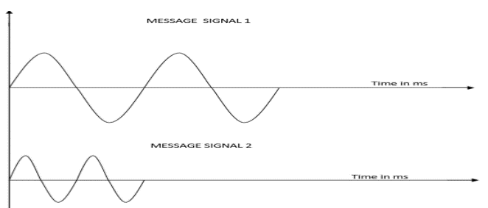
Result
The multiplexed signal was successfully demultiplexed at the receiver. The recovered output frequencies matched the transmitted frequencies, confirming the successful operation of the TDM system.
Question 1
Using the TDM trainer kit, multiplex four input signals and observe the composite TDM waveform.
Case 1: CH0 = 250 Hz
Case 2: CH1 = 500 Hz
Tasks
- Connect all four input signals.
- Perform multiplexing.
- Observe the TDM output waveform.
- Verify that all channels are present in the multiplexed signal.
- Record the observations.

Aim  (10) | Tabular Column/ Program  (20) | Procedure/ Calculations  (20) | Results  (20) | Record  (10) | Viva  (20) | Total  (100)

Question 2
Using the TDM Trainer Kit, apply:
- Channel 1: 2 kHz sine wave
- Channel 2: 3 kHz sine wave
Perform the following:
- Generate the multiplexed TDM signal.
- Observe and record the TDM output waveform.
- Connect the TDM output to the receiver/demultiplexer section.
- Recover both original signals.
- Compare the recovered signals with the original input signals

Aim  (10) | Tabular Column/ Program  (20) | Procedure/ Calculations  (20) | Results  (20) | Record  (10) | Viva  (20) | Total  (100)

EX NO: 8a | SIMULATION AND ANALYSIS OF BPSK MODULATION USING CONSTELLATION DIAGRAMS IN MATLAB
DATE:

Objective

i) To generate BPSK symbols from a binary data sequence using phase-shift keying principles.
ii) To Plot and analyze the BPSK signal constellation in the In-Phase (I) and Quadrature (Q) plane.
iii) To investigate the effect of noise on constellation points and evaluate the resulting degradation in symbol detection performance.

Matlab code
clc;
clear;
close all;
%% Objective 1: Generate BPSK symbols
N = 1000; % Number of bits
data = randi([0 1], N, 1); % Random binary sequence
% BPSK Mapping
bpsk_symbols = 2*data - 1;
%% Objective 2: Plot BPSK Signal Constellation
figure;
subplot(1,2,1);
scatter(real(bpsk_symbols), imag(bpsk_symbols), ...
30, 'filled');
hold on;
xline(0,'k','LineWidth',1.5);
yline(0,'k','LineWidth',1.5);
grid on;
axis equal;
xlim([-1.5 1.5]);
ylim([-1 1]);
xlabel('In-Phase (I)');
ylabel('Quadrature (Q)');
title('Ideal BPSK Constellation');
%% Objective 3: Add Noise and Evaluate Performance
SNR = 5; % Signal-to-Noise Ratio (dB)
rx_signal = awgn(bpsk_symbols, SNR, 'measured');

subplot(1,2,2);
scatter(real(rx_signal), imag(rx_signal), ...
15, 'filled');
hold on;
xline(0,'k','LineWidth',1.5);
yline(0,'k','LineWidth',1.5);
grid on;
axis equal;
xlim([-2.5 2.5]);
ylim([-2 2]);
xlabel('In-Phase (I)');
ylabel('Quadrature (Q)');
title(['Noisy BPSK Constellation (SNR = ', num2str(SNR), ' dB)']);
%% Symbol Detection
detected_bits = real(rx_signal) > 0;
% Calculate Errors
num_errors = sum(data ~= detected_bits);
BER = num_errors/N;
fprintf('Number of Transmitted Bits : %d\n', N);
fprintf('Number of Bit Errors : %d\n', num_errors);
fprintf('Bit Error Rate (BER) : %f\n', BER);

Procedure:

Objective 1: Generate BPSK Symbols from a Binary Data Sequence Using Phase-Shift Keying Principles
- Initialize the MATLAB environment and define the number of bits.
- Generate a random binary sequence consisting of 0s and 1s.
- Apply BPSK modulation by mapping binary 0 to −1 and binary 1 to +1.
- Store the generated BPSK symbols for further processing.
- Verify that the symbol sequence contains only two distinct symbol values.
- Prepare the modulated symbols for constellation analysis.

Model Graph

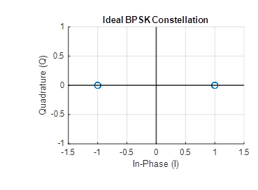
Fig: Signal Constellation for BPSK Symbols

Result BPSK symbols were successfully generated from the binary data sequence using phase-shift keying modulation.
.
Objective 2: Plot and Analyze the BPSK Signal Constellation in the In-Phase (I) and Quadrature (Q) Plane
- Use the generated BPSK symbols as inputs for constellation plotting.
- Assign the real part of the symbols to the In-Phase (I) axis.
- Set the Quadrature (Q) component to zero for all symbols.
- Plot the constellation points on the I–Q plane using a scatter plot.
- Draw the horizontal and vertical axes through the origin and label them appropriately.
- Analyze the constellation diagram and identify the symbol locations corresponding to binary 0 and binary 1.

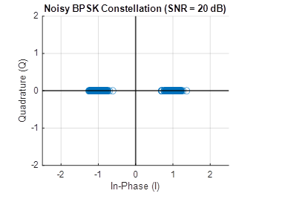
Fig. 2: Noisy BPSK Constellation

Result : The BPSK constellation was successfully plotted in the In-Phase (I) and Quadrature (Q) plane, showing two distinct symbol points corresponding to binary 0 and binary 1 for the given SNR.

Objective (iii): Investigate the Effect of Noise on Constellation Points and Evaluate the Resulting Degradation in Symbol Detection Performance
- Specify the Signal-to-Noise Ratio (SNR) for the communication channel.
- Add Additive White Gaussian Noise (AWGN) to the transmitted BPSK symbols.
- Plot the noisy constellation points on the I–Q plane.
- Observe the dispersion of constellation points around their ideal positions.
- Detect the received symbols using a threshold-based decision rule.
- Compare the detected bits with the transmitted bits and evaluate the Bit Error Rate (BER).

Tabulation

No. of data bits | SNR (dB) | No. of Error bits | BER
1000 | -5dB
1000 | 0dB
1000 | 5dB
1000 | 10dB
5000 | -5dB
5000 | 0dB
5000 | 5dB
5000 | 10dB

Model calculation

Step 1: Generate Binary Data

Consider the binary sequence:
Step 2: BPSK Symbol Mapping

Using the BPSK mapping rule:
Therefore,
Step 3: Received Symbols After Noise

Assume that after passing through an AWGN channel, the received symbols are:
Step 4: Symbol Detection

Decision rule:
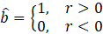Thus,
Step 5: BER Calculation

Original bits:
Detected bits:
Number of bit errors = 1
Total number of transmitted bits = 5
Bit Error Rate (BER):
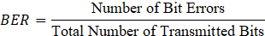
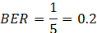

Result: The effect of AWGN noise on the constellation points was successfully analyzed, and the resulting degradation in symbol detection performance was evaluated using the Bit Error Rate (BER).

QUESTION 1
Using MATLAB, generate a Binary Phase Shift Keying (BPSK) signal using a random binary sequence of 1000 bits. Plot the BPSK constellation in the In-Phase (I) and Quadrature (Q) plane. Add AWGN noise to the transmitted symbols and observe the effect of noise on the constellation points and symbol detection performance.
Case 1:
- Number of bits,
- SNR = 15 dB
Case 2:
- Number of bits,
- SNR = 10 dB
Case 3:
- Number of bits,
- SNR = 5 dB
Tasks:
- Generate a random binary sequence and perform BPSK modulation.
- Plot the ideal BPSK constellation in the I–Q plane.
- Add AWGN noise corresponding to the specified SNR values.
- Plot the noisy constellation diagrams for each case.
- Detect the received symbols and calculate the Bit Error Rate (BER).
- Compare the constellation spreading and BER obtained for different SNR values.

Aim  (10) | Tabular Column/ Program  (20) | Procedure/ Calculations  (20) | Results  (20) | Record  (10) | Viva  (20) | Total  (100)

QUESTION 2
Using MATLAB, generate a Binary Phase Shift Keying (BPSK) signal from a binary data sequence and analyze the effect of channel noise on the constellation diagram. Observe the variation in symbol detection performance for different noise levels.
Case 1:
- Number of bits,
- SNR = 12 dB
Case 2:
- Number of bits,
- SNR = 8 dB
Case 3:
- Number of bits,
- SNR = 3 dB
Tasks:
- Generate BPSK symbols from the given binary sequence.
- Plot the ideal constellation showing the symbol locations corresponding to binary 0 and binary 1.
- Introduce AWGN noise at the specified SNR levels.
- Observe and plot the resulting noisy constellation diagrams.
- Perform symbol detection using a threshold-based decision rule.
- Calculate the BER for each case and analyze the degradation in symbol detection performance as the noise level increases.

Aim  (10) | Tabular Column/ Program  (20) | Procedure/ Calculations  (20) | Results  (20) | Record  (10) | Viva  (20) | Total  (100)

EX NO: 8b | SIMULATION AND ANALYSIS OF QPSK MODULATION USING CONSTELLATION DIAGRAMS IN MATLAB
DATE:

Objective
i) To generate QPSK symbols from a binary data sequence using quadrature phase-shift keying principles.
ii) To plot and analyze the QPSK signal constellation in the In-Phase (I) and Quadrature (Q) plane.
iii) To investigate the effect of noise on constellation points and evaluate the resulting degradation in symbol detection performance.

Matlab code

clc;
clear;
close all;

%% Objective 1: Generate QPSK Symbols
N = 1000; % Number of bits
data = randi([0 1], N, 1); % Random binary sequence

% Ensure even number of bits
if mod(N,2)~=0
data = [data; 0];
N = N + 1;
end

% Group bits into pairs
bit_pairs = reshape(data,2,[])';

% QPSK Mapping

qpsk_symbols = zeros(size(bit_pairs,1),1);
for k = 1:size(bit_pairs,1)
if isequal(bit_pairs(k,:),[0 0])
qpsk_symbols(k) = (1+1j)/sqrt(2);
elseif isequal(bit_pairs(k,:),[0 1])
qpsk_symbols(k) = (-1+1j)/sqrt(2);

elseif isequal(bit_pairs(k,:),[1 1])
qpsk_symbols(k) = (-1-1j)/sqrt(2);
elseif isequal(bit_pairs(k,:),[1 0])
qpsk_symbols(k) = (1-1j)/sqrt(2);
end
end

%% Objective 2: Plot QPSK Constellation

scatter(real(qpsk_symbols),imag(qpsk_symbols), 30);
xlim([-1 1])
ylim([-1 1])
hold on;

xline(0,'k','LineWidth',1.5);
yline(0,'k','LineWidth',1.5);

grid on;
axis equal;

xlabel('In-Phase (I)');
ylabel('Quadrature (Q)');
title('Ideal QPSK Constellation');

%% Objective 3: Add Noise and Evaluate Performance
SNR = 5;

rx_signal = awgn(qpsk_symbols,SNR,'measured');

figure;
scatter(real(rx_signal),imag(rx_signal), 15);
hold on;

xline(0,'k','LineWidth',1.5);
yline(0,'k','LineWidth',1.5);

grid on;
axis equal;
xlabel('In-Phase (I)');
ylabel('Quadrature (Q)');
title(['Noisy QPSK Constellation (SNR = ',num2str(SNR),' dB)']);

%% Symbol Detection
detected_bits = zeros(length(rx_signal)*2,1);
for k = 1:length(rx_signal)
I = real(rx_signal(k));
Q = imag(rx_signal(k));
if I>0 && Q>0
bits = [0 0];
elseif I<0 && Q>0
bits = [0 1];
elseif I<0 && Q<0
bits = [1 1];
else
bits = [1 0];
end
detected_bits(2*k-1:2*k) = bits;
end

%% BER Calculation
num_errors = sum(data ~= detected_bits);
BER = num_errors/N;
fprintf('Number of Transmitted Bits : %d\n',N);
fprintf('Number of Bit Errors : %d\n',num_errors);
fprintf('Bit Error Rate (BER) : %f\n',BER);

Objective (i): Generate QPSK Symbols from a Binary Data Sequence Using Quadrature Phase-Shift Keying Principles

Procedure:
- Initialize the MATLAB environment and define the number of bits.
- Generate a random binary sequence consisting of 0s and 1s.
- Group the binary sequence into pairs of bits.
- Apply QPSK modulation by mapping each bit pair to a unique constellation point.
- Generate the corresponding complex QPSK symbols.
- Verify that four distinct symbol values are obtained.
- Store the generated symbols for constellation analysis.

OUTPUT GRAPH

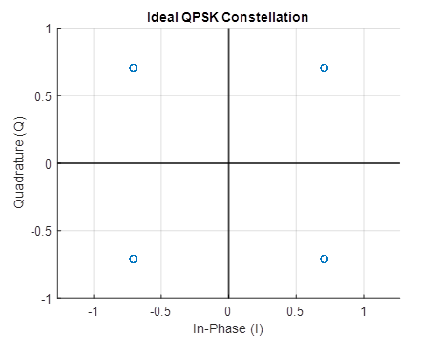

Fig. 1: Signal Constellation for QPSK Symbols

Result
QPSK symbols were successfully generated from the binary data sequence using quadrature phase-shift keying modulation.

Objective (ii): Plot and Analyze the QPSK Signal Constellation in the In-Phase (I) and Quadrature (Q) Plane

Procedure
- Use the generated QPSK symbols for constellation plotting.
- Extract the real component as the In-Phase (I) coordinate.
- Extract the imaginary component as the Quadrature (Q) coordinate.
- Plot the constellation points on the I–Q plane using a scatter plot.
- Draw the horizontal and vertical axes through the origin.
- Identify the four symbol locations corresponding to the four possible bit pairs.
- Analyze the distribution of symbols in the four quadrants.

Output Graph
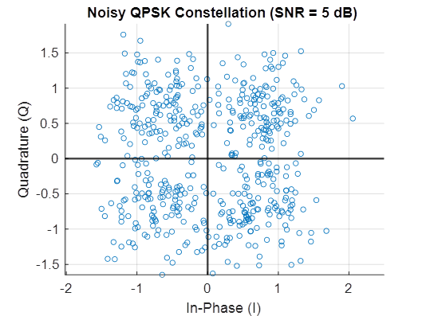

Fig. 2: Noisy QPSK Constellation

Result
The QPSK constellation was successfully plotted in the In-Phase (I) and Quadrature (Q) plane, showing four distinct symbol points corresponding to the bit pairs 00, 01, 11, and 10.

Objective (iii): Investigate the Effect of Noise on Constellation Points and Evaluate the Resulting Degradation in Symbol Detection Performance

Procedure

- Specify the Signal-to-Noise Ratio (SNR) for the communication channel.
- Add Additive White Gaussian Noise (AWGN) to the transmitted QPSK symbols.
- Plot the noisy constellation points on the I–Q plane.
- Observe the spreading of constellation points around their ideal locations.
- Detect the received symbols using quadrant-based decision boundaries.
- Recover the transmitted bit pairs from the detected symbols.
- Compare the detected bits with the transmitted bits and calculate the BER.

Tabulation

No. of data bits | SNR (dB) | No. of Error bits | BER
1000 | -5dB
1000 | 0dB
1000 | 5dB
1000 | 10dB
5000 | -5dB
5000 | 0dB
5000 | 5dB
5000 | 10dB

Model Calculation
Step 1: Generate Binary Data
Consider the binary sequence:
Group into bit pairs:
Step 2: QPSK Symbol Mapping

Using Gray-coded QPSK mapping:s=[0.707+0.707j,−0.707+0.707j,−0.707−0.707j,0.707−0.707j]

Step 3: Received Symbols After Noise
Assume the received symbols after AWGN are:
Step 4: Symbol Detection
Detected bit pairs:
Detected bit sequence:

Step 5: BER Calculation
Original bits:
Detected bits:
Number of bit errors = 0
Total number of transmitted bits = 8
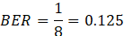
Result
The effect of AWGN noise on the QPSK constellation points was successfully analyzed, and the resulting degradation in symbol detection performance was evaluated using the Bit Error Rate (BER).

QUESTION 1
Using MATLAB, generate a Quadrature Phase Shift Keying (QPSK) signal using a random binary sequence of 1000 bits. Plot the QPSK constellation in the In-Phase (I) and Quadrature (Q) plane. Add AWGN noise to the transmitted symbols and observe the effect of noise on the constellation points and symbol detection performance.
Case 1:
- Number of bits, N = 1000
- SNR = 15 dB
Case 2:
- Number of bits, N = 1000
- SNR = 10 dB
Case 3:
- Number of bits, N = 1000
- SNR = 5 dB
Tasks:
- Generate a random binary sequence and group the bits into pairs.
- Perform QPSK modulation by mapping each bit pair to a QPSK symbol.
- Plot the ideal QPSK constellation in the I–Q plane.
- Add AWGN noise corresponding to the specified SNR values.
- Plot the noisy constellation diagrams for each case.
- Detect the received symbols using quadrant-based decision boundaries.
- Calculate the Bit Error Rate (BER) for each SNR value.
- Compare the constellation spreading and BER obtained for different SNR values.

Aim  (10) | Tabular Column/ Program  (20) | Procedure/ Calculations  (20) | Results  (20) | Record  (10) | Viva  (20) | Total  (100)

QUESTION 2
Using MATLAB, generate a Quadrature Phase Shift Keying (QPSK) signal from a binary data sequence and analyze the effect of channel noise on the constellation diagram. Observe the variation in symbol detection performance for different noise levels.
Case 1:
- Number of bits, N = 500
- SNR = 12 dB
Case 2:
- Number of bits, N = 500
- SNR = 8 dB
Case 3:
- Number of bits, N = 500
- SNR = 3 dB
Tasks:
- Generate QPSK symbols from the given binary sequence by grouping the bits into pairs.
- Plot the ideal constellation showing the four symbol locations corresponding to the bit pairs 00, 01, 11, and 10.
- Introduce AWGN noise at the specified SNR levels.
- Observe and plot the resulting noisy constellation diagrams.
- Perform symbol detection using quadrant-based decision rules.
- Recover the transmitted bits from the detected symbols.
- Calculate the BER for each case.
- Analyze the degradation in symbol detection performance as the noise level increases and compare the constellation patterns obtained for different SNR values.
Aim  (10) | Tabular Column/ Program  (20) | Procedure/ Calculations  (20) | Results  (20) | Record  (10) | Viva  (20) | Total  (100)

EX NO: 9 | SIMULATION OF CONVOLUTIONAL CODES AND ANALYSIS OF ENCODED OUTPUT BIT SEQUENCES USING MATLAB
DATE:

Objectives
(i) To implement convolutional encoding for a given binary input sequence using a rate convolutional encoder and tabulate the corresponding encoded output pairs.
(ii) To visualize and compare the input bit sequence and encoded output bit sequence using MATLAB plots to analyze the redundancy introduced by convolutional coding.
MATLAB code
clc;
clear;
close all;
% Fixed input sequence
input_bits = [1 0 0 1 1];
% Convolutional encoder
trellis = poly2trellis(3,[7 5]);
encoded_bits = convenc(input_bits,trellis);
% Separate encoded bits into pairs
encoded_pairs = reshape(encoded_bits,2,[])';
% Create output strings
for i = 1:length(input_bits)
output_pair{i} = sprintf('%d%d', ...
encoded_pairs(i,1),encoded_pairs(i,2));
end
% Create table
Bit_Position = (1:length(input_bits))';
Input_Bit = input_bits';
Output_Encoded = output_pair';
T = table(Bit_Position,Input_Bit,Output_Encoded);
disp('Convolutional Encoding Table');
disp(T);
% Plot
figure;
subplot(2,1,1)
stairs(input_bits,'LineWidth',1.5)
ylim([-0.2 1.2])
title('Input Bit Sequence')
xlabel('Bit Position')
ylabel('Bit Value')
grid on
subplot(2,1,2)
stairs(encoded_bits,'LineWidth',1.5)
ylim([-0.2 1.2])
title('Encoded Output Bit Sequence')
xlabel('Bit Position')
ylabel('Bit Value')
grid on
Objective ::
To implement convolutional encoding for a given binary input sequence using a rate convolutional encoder and tabulate the corresponding encoded output pairs.
Procedure
- Open MATLAB and create a new script file.
- Initialize the MATLAB workspace using clc, clear, and close all.
- Define the input bit sequence as .
- Create a convolutional encoder trellis using a constraint length of 3 and generator polynomials .
- Encode the input sequence using the convenc() function.
- Group the encoded bits into pairs corresponding to each input bit.
- Create and display a table containing the bit position, input bit, and encoded output pair.
- Observe the encoded output pairs generated by the encoder.

Tabulation

Bit position | Input bit | Encoded sequence
1 | 1 | 11
2 | 0 | 10
3 | 0 | 11
4 | 1 | 11
5 | 1 | 01

Result
The convolutional encoder was successfully implemented using a constraint length of 3 and generator polynomials . The input bit sequence was encoded into the output sequence 1110111101, and the corresponding encoded output pairs were tabulated successfully.
Objective (ii): To visualize and compare the input bit sequence and encoded output bit sequence using MATLAB plots to analyze the redundancy introduced by convolutional coding.
Procedure
- Create a figure window in MATLAB.
- Plot the input bit sequence using the stairs() function in the first subplot.
- Label the axes and provide a suitable title.
- Plot the encoded output bit sequence using the stairs() function in the second subplot.
- Label the axes and provide a suitable title.
- Enable the grid for clear visualization.
- Compare the input and encoded sequences.
- Observe that the encoded sequence contains twice as many bits as the input sequence due to the rate encoding process.
Model graph
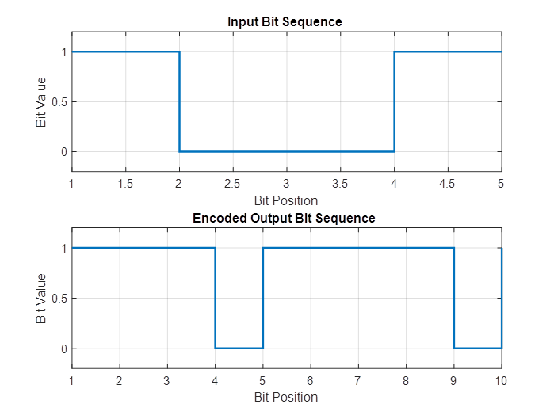
Fig. Input and Encoded sequence
Result:
The input and encoded bit sequences were plotted using MATLAB. The encoded sequence contained 10 bits for 5 input bits, confirming a rate convolutional code. The plots clearly demonstrated the redundancy introduced by convolutional encoding, which enhances the error-correction capability of digital communication systems.
QUESTION 1
Using MATLAB, implement a convolutional encoder with constraint length and generator polynomials . Encode different binary input sequences and analyze the corresponding encoded output pairs and waveform representations.
Case 1:
- Input Bit Sequence =
- Constraint Length = 3
- Generator Polynomials =
Case 2:
- Input Bit Sequence =
- Constraint Length = 3
- Generator Polynomials =
Case 3:
- Input Bit Sequence =
- Constraint Length = 3
- Generator Polynomials =
Tasks:
- Define the given binary input sequence in MATLAB.
- Create the convolutional encoder trellis using the specified constraint length and generator polynomials.
- Perform convolutional encoding using the convenc() function.
- Group the encoded bits into output pairs corresponding to each input bit.
- Create a table showing the bit position, input bit, and encoded output pair.
- Plot the input bit sequence using a staircase plot.
- Plot the encoded output bit sequence using a staircase plot.
- Compare the encoded outputs obtained for the different input sequences.

Aim  (10) | Tabular Column/ Program  (20) | Procedure/ Calculations  (20) | Results  (20) | Record  (10) | Viva  (20) | Total  (100)

QUESTION 2
Using MATLAB, implement a rate convolutional encoder and investigate the effect of varying the input sequence length on the encoded output length and code rate.
Case 1:
- Input Bit Sequence Length = 5 bits
- Example Input =
Case 2:
- Input Bit Sequence Length = 8 bits
- Random Binary Sequence
Case 3:
- Input Bit Sequence Length = 10 bits
- Random Binary Sequence
Tasks:
- Generate the specified binary input sequence for each case.
- Define the convolutional encoder with constraint length 3 and generator polynomials .
- Encode the input sequence using MATLAB.
- Determine the encoded output sequence length for each case.
- Calculate the code rate using:
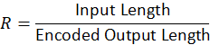
Tabulate the input length, encoded output length, and code rate.
- Plot the input and encoded bit sequences for each case.
- Compare the relationship between input sequence length, encoded sequence length, and code rate, and verify the operation of the rate convolutional encoder.

Aim  (10) | Tabular Column/ Program  (20) | Procedure/ Calculations  (20) | Results  (20) | Record  (10) | Viva  (20) | Total  (100)

EX NO: 10 | CALCULATION OF PROCESSING GAIN AND GENERATION OF PN SEQUENCES FOR SPREAD SPECTRUM COMMUNICATION USING MATLAB SIMULATION
Date:

Objectives

i) To calculate the processing gain for various PN sequence lengths and tabulate the corresponding processing gain values.
ii) To visualize and compare the processing gain obtained for different PN sequence lengths using MATLAB plots and analyze the effect of sequence length on spread spectrum performance.

PROGRAM (MATLAB Code)
clc;
clear;
close all;
% PN sequence lengths
PN_length = [7 15 31 63 127 255 511 1023];
% Processing Gain (Linear)
PG_linear = PN_length;
% Processing Gain in dB
PG_dB = 10*log10(PG_linear);
% Display table
T = table(PN_length',PG_dB',...
'VariableNames',{'PN_Length','Processing_Gain_dB'});
disp('Processing Gain Table');
disp(T);
% Plot
figure;
stem(PN_length,PG_dB,'filled');
grid on;
xlabel('PN Sequence Length');
ylabel('Processing Gain (dB)');
title('Spread Spectrum: Processing Gain vs PN Sequence Length');

Objective 1:

To calculate the processing gain for various PN sequence lengths and tabulate the corresponding values.

Procedure
1. Open MATLAB and create a new script file.
2. Initialize the MATLAB workspace using clc, clear, and close all.
3. Define the PN sequence lengths.
4. Calculate the processing gain in linear scale.
5. Convert the processing gain into decibels.
6. Create a table containing PN sequence lengths and corresponding processing gains.
7. Display the table in the MATLAB command window.
8. Observe the variation in processing gain for different PN sequence lengths.

Tabulation
PN Sequence Length | Processing Gain (dB)
7 | 8.45
15 | 11.76
31 | 14.91
63 | 17.99
127 | 21.04
255 | 24.07
511 | 27.08
1023 | 30.10

Result
The processing gain values for different PN sequence lengths were calculated successfully. It was observed that the processing gain increased as the PN sequence length increased.
Objective 2:

To visualize and compare the processing gain obtained for different PN sequence lengths using MATLAB plots.

Procedure
1. Create a figure window in MATLAB.
2. Plot the PN sequence length on the x-axis.
3. Plot the processing gain in dB on the y-axis.
4. Use the stem() function to display discrete processing gain values.
5. Label the axes and provide a suitable title.
6. Enable the grid for better visualization.
7. Compare the processing gain values corresponding to different PN sequence lengths.
8. Observe the trend between PN sequence length and processing gain.

Output
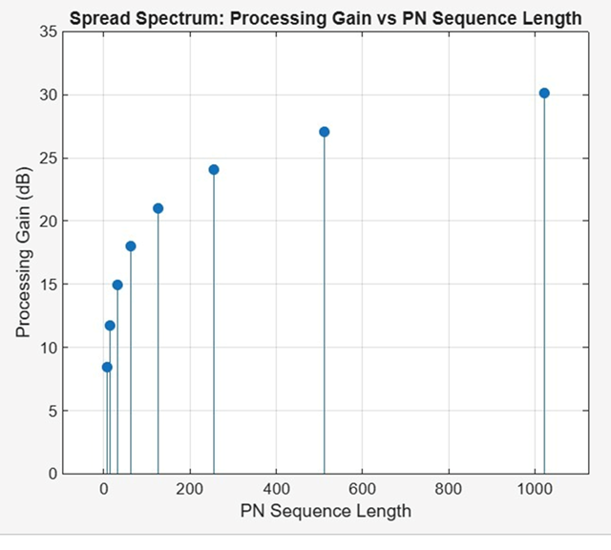
Fig. Processing Gain versus PN Sequence Length
The graph shows that the processing gain increases with PN sequence length. The increase follows a logarithmic trend because the processing gain is proportional to 10 log10(N).

Result
The MATLAB plot successfully illustrated the relationship between PN sequence length and processing gain. Longer PN sequences produced higher processing gains, thereby improving interference rejection and communication reliability.

Question 1
Using MATLAB, calculate the processing gain for different PN sequence lengths and compare the obtained values.

Case 1: PN Sequence Length = 31

Case 2: PN Sequence Length = 127

Case 3: PN Sequence Length = 511

Tasks
1. Define the PN sequence length.
2. Calculate the processing gain.
3. Convert the processing gain into dB.
4. Tabulate the results.
5. Plot the processing gain values.
6. Compare the obtained values.

Aim  (10) | Tabular Column/ Program  (20) | Procedure/ Calculations  (20) | Results  (20) | Record  (10) | Viva  (20) | Total  (100)

Question 2
Using MATLAB, investigate the effect of varying PN sequence length on processing gain.

Case 1: PN Sequence Length = 7

Case 2: PN Sequence Length = 63

Case 3: PN Sequence Length = 1023

Tasks
1. Calculate the processing gain for each PN sequence length.
2. Convert the processing gain into dB.
3. Tabulate the obtained values.
4. Plot the results.
5. Compare the processing gains.
Aim  (10) | Tabular Column/ Program  (20) | Procedure/ Calculations  (20) | Results  (20) | Record  (10) | Viva  (20) | Total  (100)

